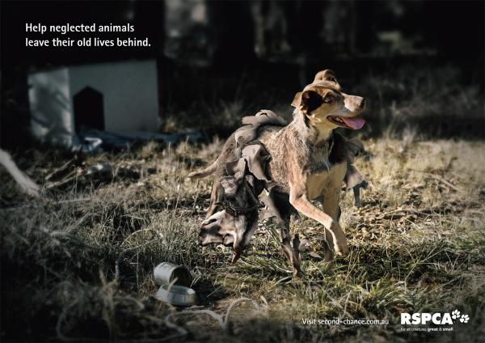

[](http://www.google.com/imgres?imgurl=http://images.businessweek.com/ss/06/07/coke_ads/image/w6949-lo.jpg&imgrefurl=http://images.businessweek.com/ss/06/07/coke_ads/source/7.htm&usg=__iUBz5L0U-gW_EUs8l3HPE8h8OQM=&h=360&w=400&sz=41&hl=en&start=14&zoom=1&tbnid=EQXIum7Fct7EpM:&tbnh=116&tbnw=129&prev=/images?q=popular+ads&um=1&hl=en&biw=1345&bih=536&tbs=isch:1&um=1&itbs=1&iact=hc&vpx=394&vpy=212&dur=2705&hovh=213&hovw=237&tx=146&ty=176&ei=ZYMFTaOZFoO78gbM0dT3Ag&oei=XIMFTcusG4T7lweBv7m3Dw&esq=2&page=2&ndsp=24&ved=1t:429,r:2,s:14)

**1**

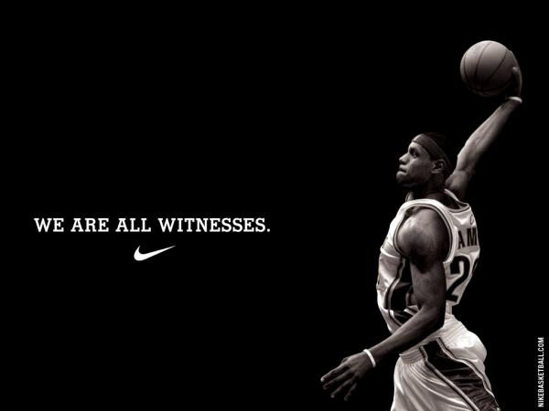

**2**



**3**

**4**





**5**





**6**



**7**



**8**



**9**



**10**



**11**

[](http://www.google.com/imgres?imgurl=http://1.bp.blogspot.com/_0lpEacFihC8/TN-28ZFeHJI/AAAAAAAAA0c/RC1zgTw83pM/s400/sexist_ads_1.jpg&imgrefurl=http://joannastaceypinto.blogspot.com/&usg=__EhXKCptHXYmYT121uvCAiiiS_CA=&h=353&w=400&sz=38&hl=en&start=24&zoom=1&tbnid=Y2lB0O58Ym6vqM:&tbnh=115&tbnw=130&prev=/images?q=sterotyping+ads&um=1&hl=en&biw=1345&bih=536&tbs=isch:1&um=1&itbs=1&iact=hc&vpx=112&vpy=198&dur=7014&hovh=211&hovw=239&tx=122&ty=119&ei=w4kFTeO4KcGqlAeu29X9Bw&oei=tYkFTYTVAYGclgf9rMDQCQ&esq=2&page=2&ndsp=27&ved=1t:429,r:9,s:24)[](http://www.google.com/imgres?imgurl=http://stopthecap.com/wp-content/uploads/2010/03/sprint-compare.jpg&imgrefurl=http://stopthecap.com/category/providers/sprint-providers/&usg=__vX-EMD8TKRq3LQGfizyu3NL1wRU=&h=307&w=294&sz=57&hl=en&start=0&zoom=1&tbnid=z_H39YINQe765M:&tbnh=123&tbnw=118&prev=/images?q=sprint+ads+calling+out+verizon&um=1&hl=en&biw=1345&bih=536&tbs=isch:1&um=1&itbs=1&iact=hc&vpx=426&vpy=55&dur=11208&hovh=229&hovw=220&tx=100&ty=117&ei=q4QFTaGnOoOKlwfIwsHZCQ&oei=q4QFTaGnOoOKlwfIwsHZCQ&esq=1&page=1&ndsp=23&ved=1t:429,r:2,s:0)[](http://www.google.com/imgres?imgurl=http://images.businessweek.com/ss/06/07/coke_ads/image/w6949-lo.jpg&imgrefurl=http://images.businessweek.com/ss/06/07/coke_ads/source/7.htm&usg=__iUBz5L0U-gW_EUs8l3HPE8h8OQM=&h=360&w=400&sz=41&hl=en&start=14&zoom=1&tbnid=EQXIum7Fct7EpM:&tbnh=116&tbnw=129&prev=/images?q=popular+ads&um=1&hl=en&biw=1345&bih=536&tbs=isch:1&um=1&itbs=1&iact=hc&vpx=394&vpy=212&dur=2705&hovh=213&hovw=237&tx=146&ty=176&ei=ZYMFTaOZFoO78gbM0dT3Ag&oei=XIMFTcusG4T7lweBv7m3Dw&esq=2&page=2&ndsp=24&ved=1t:429,r:2,s:14)

**12**