Article of the Week #21
Name: _________________________________

* Circle words that are unfamiliar and define using context clues.
* Write comments that show you understand the text.
* Create a subtitle for each paragraph – this subtitle should represent the paragraph’s most important ideas!

Annotation Rubric | Exceeds Expectations | Meets Expectations | Progressing | Not There Yet
 | Strong evidence of interaction with the text. | Good evidence of interaction with the text. | Some evidence of interaction with the text. | Little/no evidence of interaction with the text.
 | 50 points | 40 points | 30 points | 20 points  (or below)

Excerpt from “Against All Odds: Earth’s Fragile Pioneers”
by Stephen James O’Meara, Odyssey Magazine

- One species every 70,000 years! That’s the rate at which plants and animals once colonized the Hawaiian Islands. Countless millions of them had the chance, but only the most rugged pioneers—a salt-resistant seed, an insect clinging to a raft of wood, a strong-winged bird—survived the long voyage across the pacific from their native continents. Of the hundreds of species that did make it to Hawaii, only a few survived the seclusion and harshness of the burning volcanic islands. It took time, but these barren new “worlds,” risen from the sea and born of fire, finally surrendered to the slow but persistent assault of life.

- Of course, the story of the invasion of life is similar all across the globe. But what makes the Hawaii story special is the incredible distance life had to travel to get there. Remote and alone in the heart of the North Pacific, Hawaii is the most isolated island group on Earth… Yet, life did get to Hawaii, and it did so in three ways: by wind, wings, and water.

- Wind. Many of Hawaii’s plants, spiders, and insects have origins in Asia, thanks to a torrent of thin air called the jet stream, which roars across the upper atmosphere with hurricane force. Each January, the eastward-flowing jet stream makes a southerly meander over Asia. As the wind in the jet stream moves away from Asia, it slows to a minimum of about 110kph just over Hawaii. Are you getting the picture? Quite a transport mechanism here! Now, picture this: A gale-force wind in Asia strips a plant of its seeds and lifts a few spiders and insects off the ground, making them airborne…where they are then transported eastward at hurricane force until the winds slow and seeds, spiders, and insects sprinkle down on the islands. The entire journey can take just four hours!

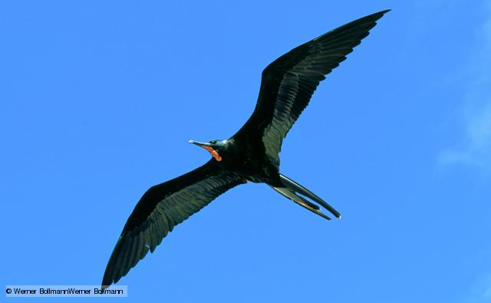
- Wings. Insects, seeds, and spiders (as well as other life forms) can take alternate means of transport to Hawaii—such as hitching a ride on a migrating or storm-driven bird. With a wingspan of over two meters, the great frigate bird is a soaring wonder. Its powerful wings can carry it effortlessly across the tropical Pacific. Now imagine one of these gets caught in a hurricane. It soars with the wind until it sights land—in this case, Hawaii. After a long journey, it rests. A seed from a favorite berry it has eaten drops into a crevice and, in time, takes root. Years later, another great flier arrives. Preening itself, the bird frees a seed or a sticky land snail from its feathers. One by one, over the millennia, these birds have transported troops of accidental “tourists” to Hawaii.
The great frigate bird in flight

- Water. Partnered with the wind, surface currents waltz around the world’s oceans, carrying with them all sorts of debris. Few seafaring seeds have what it takes to survive the long, meandering journey to Hawaii… One plant whose seeds meet these requirements is the Hala—one of the world’s oldest known flowering plants, dating back 250 million years. How do its seeds survive the salty ocean? They are snuggled in a blanket of spongy material, which can float in the seat for months or even years. A species of Hawaiian crickets rafted in on pieces of floating wood. They had to struggle to survive on harsh Hawaii, feeding on organic debris tossed to shore by wind and wave. They soon adapted, however, giving rise to an endemic specis—one found nowhere else on Earth.
- According to the text, what are the three ways new life arrived in Hawaii?

- Birds, Humans, Insects
- Weather, Wind, Wings
- Insects, Fish, Birds
- Wind, Water, Wings

- What is the author’s purpose of this passage?

- To persuade
- To entertain
- To inform
- To reflect

- Which of the following is the best statement of the central idea of “Against All Odds: Earth’s Fragile Pioneers”?

- The story of the invasion of life is nearly the same everywhere in the world
- Hawaii’s story is unique because of the great distance life traveled to get there
- The jet stream causes the wind to move away from Asia and blow right over Hawaii
- Certain species, such as Hawaiian crickets, struggle and adapt to survive

- What does the word preening mean as used in paragraph 4?

- Grooming
- Departing
- Flying
- Sleeping

- Which sentence best expresses the central idea of the entire article?

- “One species every 70,000 years! That’s the rate at which plants and animals once colonized the Hawaiian Islands.”
- “It took time, but these barren new ‘worlds,’ risen from the sea and born of fire, finally surrendered to the slow but persistent assault of life.”
- Remote and alone in the heart of the North Pacific, Hawaii is the most isolated island group on Earth.”
- “They had to struggle to survive on harsh Hawaii, feeding on organic debris tossed to shore by wind and wave.”

- The central idea of paragraph 3 is that wind helped bring plant and animal life to Hawaii. Which sentence from the paragraph best conveys that central idea?

- “Each January, the eastwards-flowing jet stream makes a southerly meander over Asia.”
- “As the wind in the jet stream moves away from Asia, it slows to a minimum, of about 110 kph just over Hawaii.”
- “Many of Hawaii’s plants, spiders, and insects have origins in Asia, thanks to a torrent of thin air called the jet stream, which roars across the upper atmosphere with hurricane force.”
- “The entire journey can take just four hours!’

- Which detail best conveys the central idea of paragraph 4?

- Insects and seeds travel on birds that migrate or flee from storms.
- The great frigate bird has an impressive, two-meter wingspan.
- Berry seeds often drop into cracks and crevices and start to root.
- Birds can loosen seeds and snails when they preen their feathers.

- Complete the table to determine the meaning of seclusion as used in paragraph 1.
Word | Context Definition | Context Clues
Seclusion  Paragraph 1 |  | “Hawaii is the most isolated island group on Earth.”

