Article of the Week #7
Name: _______________________________
* Circle words that are unfamiliar and define using context clues.
* Underline 3 sentences in the text that you have questions about, write the question in the margin
* Put a star next to 3 things you find interesting. Write down what you find interesting in the margin.
* Put a box around 2 pieces things you can make a connection to, write your connection in the margin
* Highlight

Annotation Rubric | Exceeds Expectations | Meets Expectations | Progressing | Not There Yet
 | Strong evidence of interaction with the text. | Good evidence of interaction with the text. | Some evidence of interaction with the text. | Little/no evidence of interaction with the text.
 | 50 points | 40 points | 30 points | 20 points  (or below)

Barbershop gives special discount to kids who read aloud
By Jennifer Earl CBS News October 17, 2016
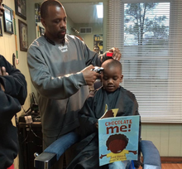
In this small barbershop in Ypsilanti, Michigan, kids pick out a book and head to the chair.
It’s like clockwork.
That’s because children 12 and under who visit The Fuller Cut can get a $2 discount on their $11 haircut for doing a simple task: reading to the barber.
It’s a program owner Alexander Fuller and barber Ryan Griffin started more than a year ago.
And parents can’t get enough of it.
Ryan Griffin works on trimming a young boy’s hair as he reads aloud.
Almost all of Griffin's clientele is African-American. He offers his younger visitors books that they will enjoy but also have a strong, positive message.
The Fuller Cut
“We’ve been doing this for a long time,” Fuller explained. “When it gets busy people take notice -- parents are really receptive of it; they love it.”
The pair can’t take credit for the idea. They just happened to hear about other shops around the country taking part in a “read to your barber program,” and they decided to get on board.
Fuller and his wife started ordering some books and Griffin brought in a shelf. Customers even joined the cause by donating old and used books.
Before the pair knew it, kids were grabbing books off the shelf and hopping into the chair to start reading.
Roughly 90 percent of kids grab a book that’s already on the shelf, Fuller says, but occasionally kids bring in books from home or school as well.
“It gives them confidence in reading and helps us understand their comprehension of reading,” Fuller said. “The kids love it. It’s one of the best things that has come along for them.”
Griffin agreed that this has been worthwhile, “You know, maybe someday some kid will grow up and be a journalist, be a writer, and he'll say, 'You know what, when I was young, my barber used to make me read.'
Another bonus, Fuller added, is that it helps kids socialize. Not only does it improve their reading skills, but their manners as well.
Whether you can read well or can’t read well, the barbers will help you along the way, Fuller reminds his customers.
“It’s been a great experience so far, Fuller said.”

Monday:
Read the article and annotate following the annotation directions at the top of the page.
Tuesday:
- Write a one sentence summary of what the article is about.

- Where do children get the books to read?

- What is the meaning of the word clientele, as used in the following sentence “Almost all of Griffin’s clientele is African American”.

Wednesday: Answer the following questions in complete sentences.

Make an inference: How are Fuller and Griffin helping to create a love of reading in their community? Explain your answer in at least two sentences.

Make an inference: Do you think Fuller and Griffin have created a sense of belonging in their community for young children? Explain your answer in at least two sentences.
Thursday: Complete the Bubble Map below with at least three positive effects of reading.

Positive Effects of reading

Want to know more about this topic?
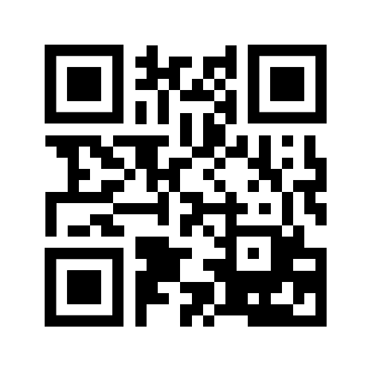
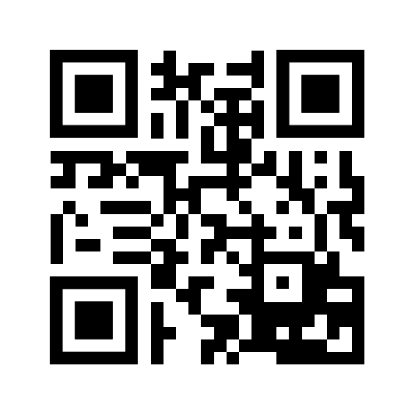
Video of kids reading to barber
http://tinyurl.com/h5f3b62
List of freebies for a good report card!
http://tinyurl.com/dxq3qmw

