Article of the Week #8
Name: _______________________________
* Circle at least three of the following words and define them in the margins using context clues:
ordinary, reattached, standout, limited, mobility
* Underline sentences from the text that you have questions about. Write your questions in the margins
* Highlight information about the obstacles Michelle faces.
* Make at least two text-to-text connections. Put a box around information you can connect to your Game Changer from the Game Changer project. In the margin, write the connection.

Annotation Rubric | Exceeds Expectations |  | Meets Expectations | Progressing | Not There Yet
 | Strong evidence of interaction with the text. |  | Good evidence of interaction with the text. | Some evidence of interaction with the text. | Little/no evidence of interaction with the text.
 | 50 points |  | 40 points | 30 points | 20 points  (or below)
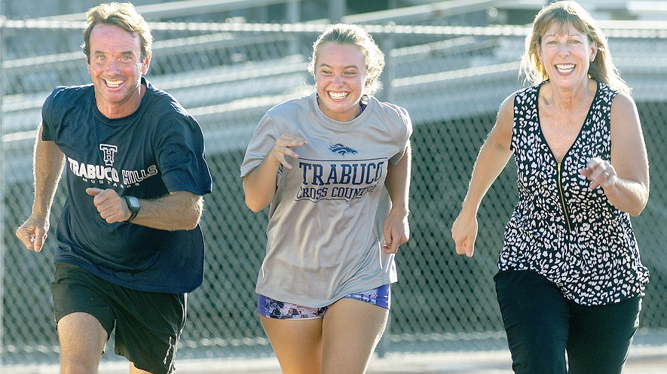

Teen Runner with Disability Races to the Finish Line
By Orange County Register, adapted by Newsela 9.22.16

MISSION VIEJO, Calif. — Darrell Cross had spent plenty of time trying to teach his nearly 10-year-old daughter, Michelle, how to ride a bike. She still was having trouble learning, though, even with training wheels.

A bicycle shop employee told him to take off the pedals and let her push herself on the bike using her feet. Turns out, he was on to something.

With the pedals removed, Michelle guided the bicycle through the neighborhood for an entire weekend. Soon after, with pedals reattached, she was riding like a pro.

"It introduced us to this whole new world of being able to go out and ride a bike together as a family," Darrell Cross said. Such family moments are usually ordinary, but this one was very special.

Physical Challenges Don't Hold Her Back

Michelle, now 16, was born with cerebral palsy. The condition has left her with limited balance and movement on her entire right side, and she can barely use her right arm at all. Simple things, like tying shoes and putting her hair up, are extremely challenging.

However, none of that has stopped her from becoming an excellent athlete.

Michelle, a junior at Trabuco Hills High, is a three-year member of the school's cross country and track teams. She has three bronze medals from last spring's state championships to her credit. Before taking up distance and track running, she was a standout in youth soccer.

"She played goalie, but she would bat that ball away with her left hand," said Melanie Cross, Michelle's mother.
"Some of the high school coaches knew her because they'd seen her play."

Older Sister Is Always On Her Team

Michelle has a competitive spirit and a fun-loving personality. Both are the result of an incredibly supportive neighborhood in Rancho Santa Margarita.

Michelle grew up wearing braces and, for a time, an eye patch. She had to work hard to keep up with the neighborhood kids. Falls were common, but she received plenty of encouraging words and much support.
No one was more supportive than older sister Emily. When the two were growing up, Emily Cross helped Michelle into the family car, tied her shoes and patiently taught her everyday tasks, including how to get dressed on her own.

"She's helped me a lot," Michelle said. "She's been influencing me with everything, she's always been assisting, and I've always looked up to her. When I was little, I would always follow her."

Emily Cross, 18, also played soccer as a youth but turned to running when she did not make the girls soccer team.

When Michelle reached her first year in high school, she followed her sister's lead. Her disability did not make things easy. Because of her limited balance, she has had more than her fair share of spills on the track. Her limited right side mobility forces her right foot to pound into the ground with each step.

Michelle works hard and never gives up, said Dennis Kelly, Trabuco Hills' girls track and field coach. "She's dedicated to what she does ... she never complains about the workouts or the weather."

Michelle gets back up and pushes on, her mother said. At a meet at Mission Viejo High, one fall led to an enormous opportunity. It was there that the family learned that the state meet would include races for athletes with physical disabilities.

A Fierce Competitor

In June 2016, the family was in Clovis, California, where Michelle competed in the state meet in the 100-, 200- and 400-meter races. She won bronze at all three events.

"I got goosebumps," Darrell Cross said. "We're planning on state again this year."

Emily Cross, now at San Francisco State University, said she got updates on her sister's progress.

"It's outstanding, beyond my words — I don't know how she does it," she said. "Running is hard enough as it is, and sometimes her foot hurts when she runs, or she can't feel it because of the constant pounding on the ground, but she still does it."

Trabuco Hills cross country coach Liam Clemons said Michelle has never used her disability as an excuse. "I feel like I can endure and handle more things than other people can because I have to work harder for it," Michelle said. "I know I have a lot of hard work to do, so I'm just going to hang in there.
Monday:
Read the article and follow the annotation directions at the top of the page.
Tuesday: Answer the following multiple choice questions.

- Read the section “A Fierce Competitor.” Darrel Cross would be MOST likely to agree with which of the following statements?
- Michelle would never have been able to run without her sister’s help.
- The entire family was very proud to watch Michelle perform well at the state meet.
- It would not be wise for Michelle to try to compete again at the state meet.
- Michelle won the races at the state meet because she has natural physical talent for running.

- How does the article develop the idea that Michelle Cross worked hard to be an exceptional athlete?
- By providing statistics about how few people with cerebral palsy are able to compete as athletes
- By giving information about medical treatments available to athletes with cerebral palsy.
- By comparing and contrasting Michelle’s athletic ability to that of a student without a disability
- By describing Michelle’s disability and the ways she has worked hard to overcome it.

- Read the italicized section in the article. What does the phrase “more than her fair share of spills” refer to?
- Michelle is not upset when she falls and gets hurt.
- Michelle falls more than most other runners.
- Michelle is able to quickly recover from her falls.
- Michelle has learned how to fall without getting injured.

- Read the following sentence from the section “Older Sister is Always on her Team.”

When the two were growing up, Emily Cross helped Michelle into the family car, tied her shoes and patiently
taught her everyday tasks, including how to get dressed on her own.

Which word or phrase from the sentence BEST shows that Emily Cross was very understanding of her sister’s condition?
- Growing up
- Patiently
- Tasks
- On her own
Wednesday: Answer the following question in complete sentences with text evidence to support your answer. Make sure to include the text evidence properly with all required elements of text evidence.

Do you consider Michelle Cross a Game Changer? Why or why not?

Thursday: On a separate sheet of paper, make a double bubble map comparing/contrasting Michelle Cross to your Game Changer from the Game Changer project. Staple your thinking map to this paper.
Interested in knowing more? Scan the QR code/enter the TinyURL to learn more about this topic!
Article and video about a horse helping a girl with cerebral palsy

http://tinyurl.com/z77mam5
Information about cerebral palsy
http://tinyurl.com/gtps45x

