Name: ____________________________________ Date: _____________________

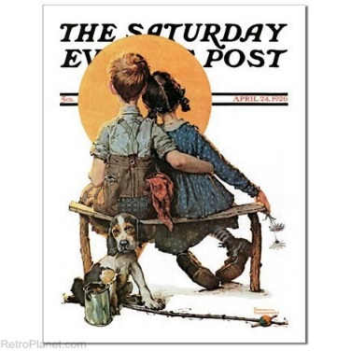
“Business at Eleven”

- Why does Johnny want to buy old magazines?

- Read the following conversation between the narrator and Johnny.

“Do you want to keep these?” he said.
“No. You can have them,” I said.
“No. I don’t want them for nothing,” he said. “How much do you want for them?”
“You can have them for nothing,” I said.
“No, I want to buy them,” he said. “How much do you want for them?

Based on the conversation, how would you describe Johnny’s character?

- What does the narrator find surprising about Johnny, compared to other eleven-year-old boys?

- Find a piece of text evidence to support your answer to question #3.

- Describe Johnny’s family.

- Based on what you know about Johnny’s family, why do you think Johnny works so hard?

- Make a prediction: How might Johnny use what he has learned in this business to reach his goals for a future career?

- Re-read the last sentence of the text. Based on the ending, do you believe Johnny will succeed in the future? Support your answer using text evidence.
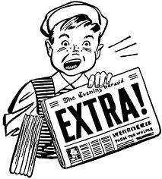

- In order to determine a story’s theme, you must first analyze the characters’ traits, the title, the main events, and the last sentence. Use the flow chart below to help you determine the theme.

Title

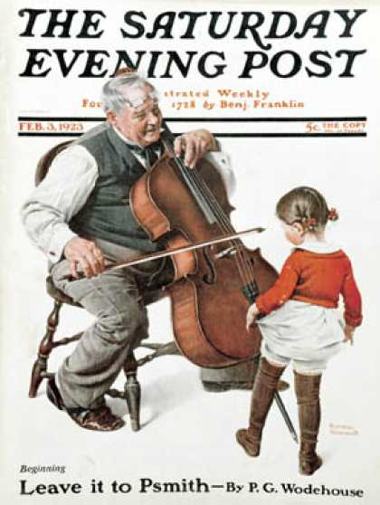
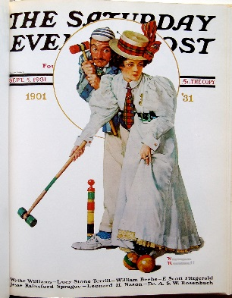
Last sentence of the story

Johnny’s character traits

1.

2.
Main events of the story

1.

2.

3.
Based on the character traits, the main events, and the last sentence, what is the story’s theme?
Theme

