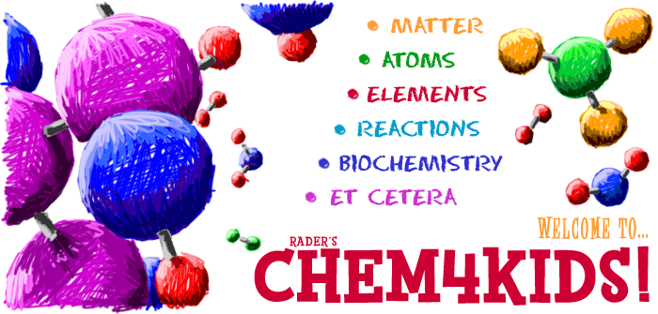
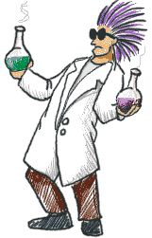
Chem4Kids General Matter Learning Lab Name_____________________________
Directions:
- Type the following link in the address bar: http://www.chem4kids.com/files/matter_intro.html
- Make sure you are in the Matter section and read the information.
- As you get to the bottom of a page, click next page in Matter to go on to the next.
- Answer the following questions as you read- they are in order:
1) What is the name of the 5th state of matter that we did not study?_____________________________

2) Describe or define this 5th state of matter as best as you can. It gets easier towards the end of the description. ______________________________________________________________________________________________________________________________________________________________________________

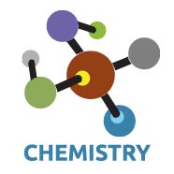
3) What needs to happen for matter to change states? (Use the Topics Column: Phase Change I)
- All matter can move from one state to another. It may require extreme temperatures or extreme
pressures.
- The text says, “Phase changes happen when you reach certain special points.”
- What did the text mean by certain special points?_______________________________________________
_______________________________________________________________________________________

4) What are the chemistry terms for the following:
Solid to a Liquid = Fusion/Melting
Liquid to a Solid = Freezing
Liquid to a Gas = Vaporization/Boiling
Gas to a Liquid = Condensation
Solid to a Gas = Sublimation
Gas to a Solid = Deposition

5) Play the video on the Aurora Borealis. https://youtu.be/PaSFAbATPvk\
What state of matter is the aurora? ___________________
6) What is the difference between a physical and a chemical change of matter? (Use the Topics Column: Chem-Phys)
- Physical changes are usually about physical states of matter or phase changes.
- Write one example of a physical change. _____________________________________________________
_______________________________________________________________________________________
-Chemical changes happen on a molecular level when you have two or more molecules that interact.
Chemical changes happen when atomic bonds are broken or created during chemical reactions.
- Write one example of a chemical change. ____________________________________________________
_______________________________________________________________________________________
- Chemical Reactions (changes) occur when two or more molecules interact and the molecules
change. Bonds between atoms are broken and created to form new molecules.
If you are lost, click on the following link. http://www.chem4kids.com/files/matter_solid.html Page 2
7) What is a heterogeneous mixture? (Use the Topics Column: Solids)
- According to the text, heterogeneous mixture mixtures have different concentrations of compounds
in different areas of the mixture. Please rewrite this so it is easier to understand.
_______________________________________________________________________________________

8) What is a crystal? (Use the Topics Column: Solids)
- A crystal is a form of solid where the atoms are arranged is a very specific order. The atoms
are arranged in a regular repeating pattern called a crystal lattice.

9) What is a solution? (Use the Topics Column: Liquids)
- Different types of molecules dissolved in a liquid, it is called a solution.
9) What is happening when something is compressed? (Use the Topics Column: Liquids)
- When you compress something, you take a certain amount of material and force it
into a smaller space or volume . You force the atoms closer together.

10) Where would we find compressed air? _______________________________________________
13) What is the difference between a vapor and a gas? (Use the Topics Column: Gases)
-Vapor and gas mean the same thing. The word vapor is used to describe gases that are usually liquids at room temperature.

15) What state of matter was created in 1995? (Use the Topics Column: BE Condensate)
Bose-Einstein Condensate

16) Why do we say this new state of matter can form a “super atom”? (Use the Topics Column: BE Condensate)
_______________________________________________________________________________________

17) What is the difference between a mixture and solution? (Use the Topics Column: Mixtures I)
Mixtures are absolutely everywhere you look. Most things in nature are mixtures . Mixtures are about physical properties, not chemical ones. Solutions are also mixtures, but all of the molecules are evenly spread out through the system.
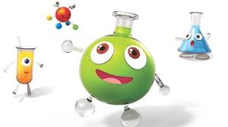
19) Fill in the chart with the missing information: (Use the Topics Column: Solutions I)
SOLUTION EXAMPLE
Gas-Gas Air
Gas-Liquid Carbon Dioxide (CO₂) in Soda
Gas-Solid Hydrogen (H₂) in Palladium (Pd) Metal
Liquid-Liquid Gasoline
Liquid-Solid Dental Fillings
Solid-Solid Metal Alloys Such as Sterling Silver

20) What is a colloid? (Use the Topics Column: Solutions I)
Colloids are solutions with bigger particles. Colloids are usually foggy or milky when you look at them. In fact, milk is an emulsified colloid.

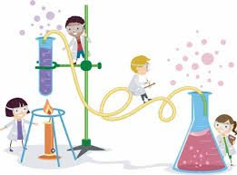

Now take some quizzes:
- Type the following into the address bar: http://www.chem4kids.com/extras/quiz_matterintro/
(General Matter Quiz) Score: ________/10
- Type the following into the address bar: http://www.chem4kids.com/extras/quiz_mattermix/index.html (Mixtures Quiz) Score: ___/10
- Type the following into the address bar: http://www.chem4kids.com/extras/quiz_mattersolution/index.html (Solutions Quiz) Score:__/10

