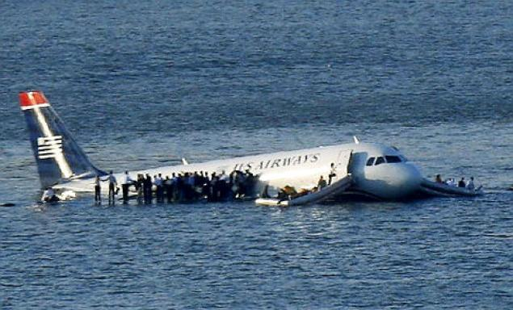
Chesley Sullenberger
On this day in 2009, a potential disaster turned into a heroic display of skill and composure when Captain Chesley Burnett Sullenberger III safely landed the plane he was piloting on New York City’s Hudson River after a bird strike caused its engines to fail. David Paterson, governor of New York at the time, dubbed the incident the “miracle on the Hudson.” Sullenberger, a former fighter pilot with decades of flying experience, received a slew of honors for his actions, including an invitation to Barack Obama’s presidential inauguration and resolutions of praise from the U.S. Congress.
About a minute after taking off from New York’s La Guardia Airport on January 15, 2009, US Airways Flight 1549 collided with one of the aviation industry’s most threatening foes: a flock of geese. Crippled by the bird strike, both engines lost power and went quiet, forcing Captain Sullenberger to make an emergency landing. When air traffic controllers instructed the seasoned pilot to head for nearby Teterboro Airport, he calmly informed them that he was “unable” to reach a runway. “We’re gonna be in the Hudson,” he said simply, and then told the 150 terrified passengers and five crew members on board to brace for impact.
Ninety seconds later, Sullenberger glided the Airbus 320 over the George Washington Bridge and onto the chilly surface of the Hudson River, where it splashed down midway between Manhattan and New Jersey. As flight attendants ushered passengers into life jackets, through emergency exits and onto the waterlogged wings of the bobbing jet, a flotilla of commuter ferries, sightseeing boats and rescue vessels hastened to the scene. One survivor suffered two broken legs and others were treated for minor injuries or hypothermia, but no fatalities occurred. After walking up and down the aisle twice to ensure a complete evacuation, Sullenberger was the last to leave the sinking plane.
In October 2009, the now-famous pilot, known to his friends as “Sully,” published a book about his childhood, military background and career entitled “Highest Duty: My Search for What Really Matters.” He retired from US Airways after 30 years in the airline industry on March 3, 2010, and has since devoted his time to consulting, public speaking and advocating for aviation safety.
The former Air Force fighter pilot remained cool, calm and collected both before and after successfully ditching his US Airways flight into the Hudson River.
"That pilot is a stud," said one police source. "After the crash, he was sitting there in the ferry terminal, wearing his hat, sipping his coffee and acting like nothing happened."
Sullenberger, 57, looks more like Clark Kent than Superman: He's balding, slightly built, with a thin mustache. But he emerged from the slowly sinking fuselage of Flight 1549 as one of Gotham's brightest heroes, able to land engineless airplanes in a single try.
"Brace for impact," he warned the passengers before ditching the plane, a voice of lone calm in the seconds before they crashed.
Sullenberger wasn't done once his plane was down. He undid his safety belt and walked the length of the plane to make sure all the passengers were safely outside, Mayor Bloomberg said.
Once finished, Sullenberger turned around and made a second pass as the plane steadily took on water - and only then did he finally exit.
"He did a masterful job of landing the plane in the river and then making sure everybody got out," said an admiring Bloomberg, who is a licensed pilot.
Sullenberger maintained his calm facade in a phone call to his wife, fitness expert Lorrie Sullenberger, after his death-defying heroics.
"When he called me, he said, 'There's been an accident,'" she told CNN. "At first I thought it was something minor. But then he told me the circumstances, and my body started shaking and I rushed to get our daughters out of school."
A still-rattled Lorrie Sullenberger said she heard about the crash on television at their East Bay area home but never made the connection that her husband was flying the plane.
"We're really proud of him," daughter Kate told the Daily News.
Sullenberger joined US Airways 29 years ago and became a well-known figure within the industry.
He's a graduate of the U.S. Air Force Academy and earned master's degrees at both Purdue University and the University of Northern Colorado. Sullenberger is also a visiting scholar at the University of California at Berkeley.
He's participated in several National Transportation Safety Board investigations - and will sit down with NTSB investigators to offer details of Thursday's crash.
He has served as safety chairman for the Air Line Pilots Association, and worked with hundreds of colleagues on safety issues.
Sullenberger founded his own company, Safety Reliability Methods, Inc., to pass on his expertise to other businesses.
His wife recalls Sullenberger saying that it's rare for a pilot to have an incident in their career. But when he finally did, the old fighter pilot proved more than equal to the task.
Answer the following questions using the above article:
- Why did U.S. Airways Flight 1549 go down?

- In the second paragraph, what effect does the word “calmly” have on the paragraph?

- Based on the context in the third paragraph, what does the word “flotilla” mean?

- What does Chesley Sullenberger do now after retiring from US Airways? Name two things this tells us about him.

- What literary device is used in the fifth paragraph? Why did the author use this literary device?

- How did Sullenberger act directly after the incident? Actions speak louder than words, so what does this tell us about Sullenberger?

- What literary device is used in the 7th paragraph? Why is this so fitting?

- Sullenberger was able to accomplish a “death-defying heroic” act. Describe (real or imaginary) someone doing another “death-defying heroic act.”

- What is the tone in the article? Provide text evidence for support.

- What is the theme of the article?

