|  |
| --- |
| **C:\Documents and Settings\jcox\Local Settings\Temporary Internet Files\Content.IE5\UG4QRZGG\MC900251265[1].wmfC:\Documents and Settings\jcox\Local Settings\Temporary Internet Files\Content.IE5\UG4QRZGG\MC900251265[1].wmfC:\Documents and Settings\jcox\Local Settings\Temporary Internet Files\Content.IE5\UG4QRZGG\MC900251265[1].wmfReading EOG Review Name:** |

**Directions:** For #1-8, match each of the literary terms with the proper text example.

|  |  |
| --- | --- |
| 1. ___ Personification 2. ___ Simile 3. ___ Metaphor 4. ___ End Rhyme 5. ___ Onomatopoeia 6. ___ Internal Rhyme 7. C:\Documents and Settings\jcox\Local Settings\Temporary Internet Files\Content.IE5\MBXJF66L\MC900366128[1].wmf___ Alliteration 8. ___ Repetition | 1. Buzz! 2. There was a young fellow named Hall,   Who fell in the spring in the fall   1. She did not realize that opportunity was knocking at her door. 2. “Let freedom ring from Lookout Mountain of Tennessee.   Let freedom ring from every hill and molehill of Mississippi.  From every mountainside, let freedom ring.”   1. He had a voice as soft as wild honey dripping from a tree. 2. Laughter is the music of the soul. 3. Becky’s beagle barked and bayed, becoming bothersome for Billy. 4. I went from zero, to my own hero |

**Directions:** Use the word bank for #9-19 to fill in the blank with the proper term.

|  |  |  |  |
| --- | --- | --- | --- |
| **C:\Program Files\Microsoft Office\MEDIA\CAGCAT10\j0195812.wmfWord Bank** | | | |
| Science Fiction  Fiction  Traditional Literature | Historical Fiction  Drama  Prose | Mystery  Nonfiction  Narrative | Genre  Poetry |

1. A ___________ is a division or type of literature. Literature is commonly divided into three major ___________s: poetry, prose, and drama.
2. _________________ is prose writing that presents and explains ideas. It also may tell about real people, places, objects, or events. Autobiographies, biographies, essays, reports, letters, and newspaper articles are all types of this division of literature.
3. ______________ is a story written to be performed by actors. Although it’s meant to be performed, one can also read the script and imagine the action. *This is one of the major genres!*
4. _______________ is prose writing that tells about imaginary characters and events. Short stories and novels are types of this division of literature.
5. In _______________________, real events, places, or people are incorporated into a fictional, or made-up, story.
6. _______________ makes use of concise, musical, and emotionally charged language. Many make use of imagery, figurative language, and rhyme. *This is one of the major genres!*
7. A __________________ is a story. It can be either fiction or nonfiction.
8. ______________________ combines elements of fiction and fantasy with scientific fact. Many stories in this genre are set in the future.
9. ___________________________ includes fictional stories that have been passed down by word of mouth. These stories are told to entertain and teach a lesson.
10. _______________ is the ordinary form of written language. It is written in paragraph form. *This is one of the major genres!*
11. In a _______________ story, characters are asked to solve a crime or puzzle or to expose a secret. The crime, puzzle, or secret is the driving force for the plot.

**Directions:** Fill in the blanks for #20-39 and then find the terms in the Word Search.

I N T E R N A L C O N F L I C T T N O C F U A L U

M D E V B O O Q T C I T D W D S B M N L H L N U R

Z X O U P I E I Q H H Z X N I B N J Z I Z H T J E

Z R D O C T N R T E I M K N R I Z J H M Q T A K P

L X V A M C O P M C P R O N S S Q Y A A I J G C G

Z A U W M A T E D R A G D C O P F J N X W I O A O

Q V V G C G U Z R I A G I P F I Y N O R I L N B T

B E Q E E N V X X T A E N R E R T N N K R E I H D

H Q T C B I O Q O O N L P I P R V I J H U L S S S

Q X S C I S O R P T V D E I L Z S V S G Q M T A T

H R O A Z I P A J I F G H C G L P O O O U W Z L G

O R Q F I R S T P E R S O N T J A L N H P J C F V

T C I L F N O C L A N R E T X E A F S Y A X E M M

E V R U T M J Q L Z R Z D Y P I O K K U T X E W V

N O I T U L O S E R R F E L D S U S P E N S E K T

1. The _________________ is the main character in a literary work.
2. The _________________ is the character or force in conflict with the main character.
3. The ______________, also called the turning point, is the high point in the action of the plot. It is the moment of greatest tension.
4. _______________ is the form of language spoken by people in a particular region or group.
5. _______________ is a conversation between characters. It is usually set off by quotation marks.
6. An __________________ narrator knows and tells about what each character feels and thinks.
7. The ________________ is the outcome of the conflict. The story comes to a reasonable ending in this part of the plot.
8. The ________________ is the part in the story that introduces the characters, setting, and basic situation.
9. A _______________ is a scene within a story that interrupts the sequence of events to relate events that occurred in the past.
10. An ____________ _____________ takes place within the mind of a character. The character struggles to make a decision, take an action, or overcome a feeling.
11. An ____________ _____________ is one in which a character struggles against some outside force, such as another person or force in nature.
12. The _____________ is the central message, concern, or purpose of a literary work.
13. _____________ is a contradiction between what happens and what is expected.
14. ____________ ____________ is made up of the main events leading up to the greatest point of interest. The conflict increases during this part of the story.
15. C:\Documents and Settings\jcox\Local Settings\Temporary Internet Files\Content.IE5\OADHIB5G\MC900304333[1].wmf____________ ____________ is the end of the central conflict. Loose ends are typically tied up in this part of the plot.
16. _____________ is the feeling created in the reader by a literary work.
17. ______________ is the writer/speaker’s attitude toward the subject and the audience.
18. ___________ ____________ point of view is told by a character in the story who uses pronouns like *I*, *me*, *my*, *we*, *us*, and *our.*
19. ____________ _____________ point of view is someone who is NOT a character in the story.
20. _______________ is the feeling of anxious uncertainty in about the outcome of events.

**Directions:** Match each term to a definition for #40-59.

|  |  |
| --- | --- |
| 1. ___ Simile 2. ___ Characterization 3. ___ Internal Rhyme 4. ___ Metaphor 5. ___ Narrator 6. ___ Symbol 7. ___ End Rhyme 8. ___ External Conflict Examples 9. ___ Plot 10. ___ Couplet 11. ___ Hyperbole 12. ___ Alliteration 13. ___ Idiom 14. ___ Onomatopoeia 15. ___ Foreshadowing 16. ___ Stanza 17. ___ Setting 18. ___ Figurative Language 19. ___ Personification 20. ___ Internal Conflict Examples   C:\Program Files\Microsoft Office\MEDIA\CAGCAT10\j0299125.wmf | 1. Rhyming words within lines 2. Comparison using like or as 3. Man vs. Self 4. The use of words or phrases that imitate sounds (ex: *click*, *snap*, *pow*) 5. Writing or speech that is not meant to be taken literally 6. A figure of speech in which one thing is spoken or written about as if it were another 7. Two-line stanza 8. A group of lines in a poem 9. Rhyming words at the ends of lines 10. The sequence of events in a story 11. The act of creating and developing a character; what the author writes to develop a character’s personality 12. The author’s use of clues to suggest/hint at what may happen later in the story 13. A speaker or character who tells a story; may be first person or third person 14. A nonhuman is given human characteristics 15. The repetition of initial consonant sounds 16. Man vs. Man; Man vs. Nature; Man vs. Society 17. The time and place of the action 18. A figure of speech in which exaggeration is used for effect or emphasis 19. A form of expression natural to a language, person, or group of people (ex: *Don’t let the cat out of the bag!)* 20. Anything that stands for or represents something else |

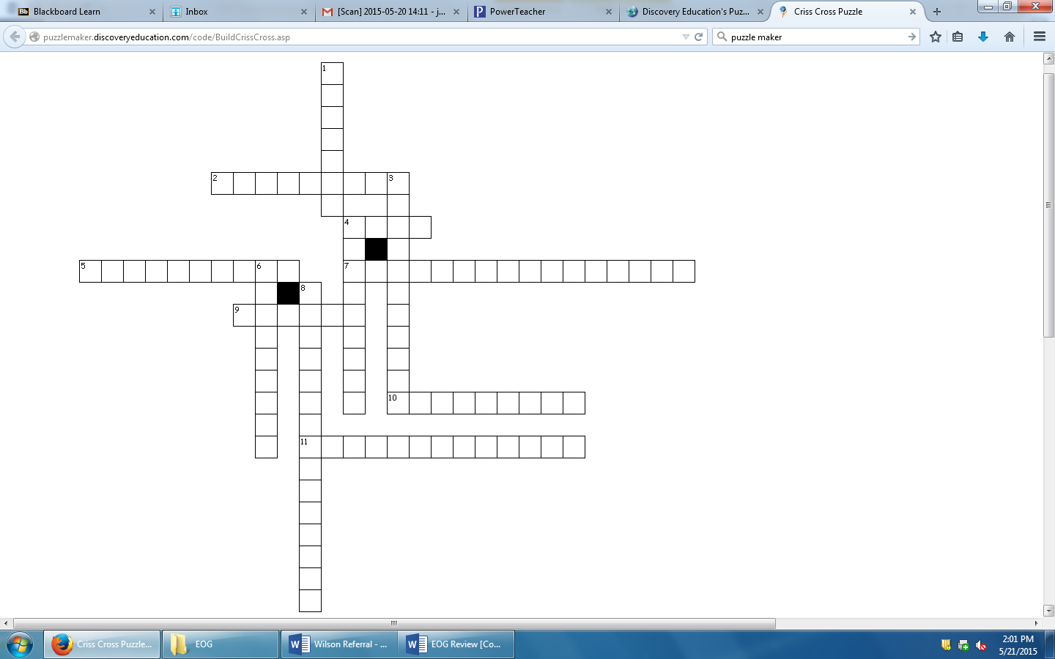

**Nonfiction Crossword**



**Directions: Use the clues to complete the Crossword Puzzle.**

**Across**

2. In this type of essay, the writer states his/her opinion about an issue. This type of writing appears in the newspaper.

4. A person's feelings and opinions. This is shaped by a person's background and where they come from.

5. This labels all members of a group as being the same and does not take individual differences into account. This often results in prejudice.

7. We see this type of argument when a writer presents only one side of a situation.

9. The writer of this type of essay describes an important memory from his/her life.

10. A source that shares information that has been collected, compiled, summarized, and maybe even changed from its original source. The information can be traced beyond its author to at least one or more sources.

11. The story of the writer’s own life, told by the writer. It may tell about the writer’s whole life or only a part of it.

**C:\Program Files\Microsoft Office\MEDIA\CAGCAT10\j0301252.wmf**

**Down**

1. An original source that shares firsthand knowledge and the information can be traced no further than its author.

3. Words that have strong emotion behind them. They are often negative. This technique is also called “Semantic Slanting."

4. An account of someone’s life written by someone else. Most of the time, these are written about famous or admirable people.

6. Pre-judgment or making assumptions about a person or group before knowing them.

8. Contrasting, refuting, or opposing argument.