Name: ______________________________________ Date: _________________________
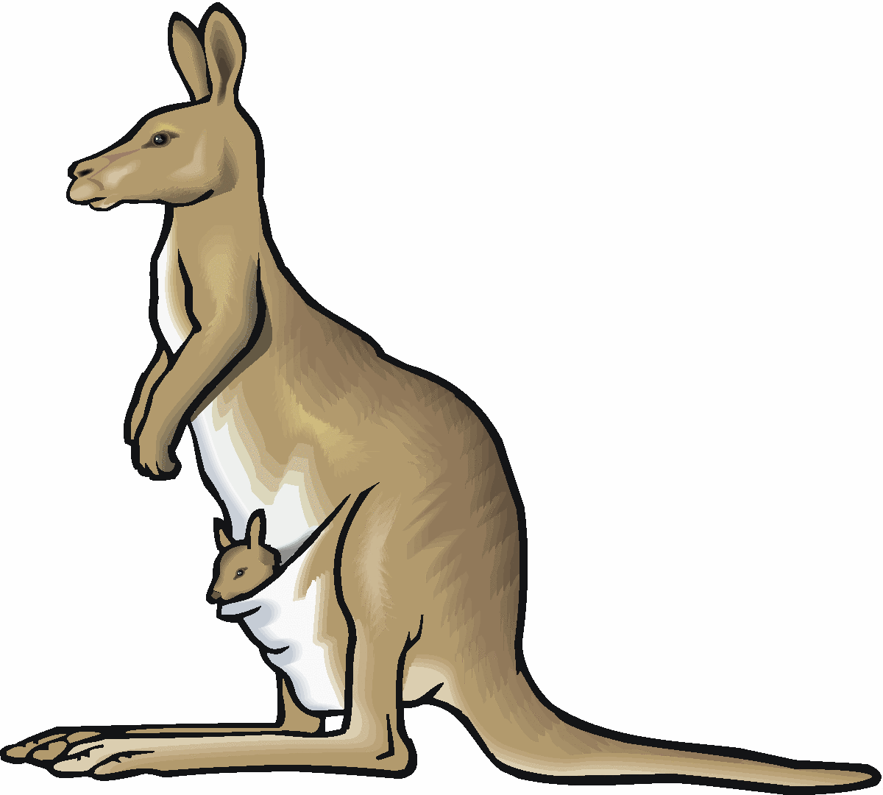
Exotic Pets
PART 1: Video Questions
Directions: Watch the video and answer the following questions

What are exotic pets?

According to the video, why do people often ignore warnings against owning exotic pets?

PART 2: Reading Questions
Directions: Read the Scope article and answer the following questions

- What is the difference between a domesticated and exotic pet?

- What are two reasons someone might want an exotic pet?

- According to the article, what is one reason why people often end up neglecting or abandoning their exotic pets?

- What is the meaning of the phrase “wreaking havoc” as used in paragraph 10?

- In the last paragraph, Jack Hanna compares sleeping with a tiger to “sleeping with a bomb.” What does Hanna mean by this comparison?

Part 3: Text Evidence Practice
Directions: Find two pieces of text evidence to support each claim

Claim | Text Evidence #1 | Text Evidence #2
Exotic pets are dangerous
Owning exotic pets is cruel
Exotic pets are just like regular pets

