Folk Tale: “He Lion, Bruh Bear, and Bruh Rabbit” Name:

Folk Tales were told not only to___________ and teach a lesson, but also to communicate the shared ideas of a _____________. They often deal with_______________, adventure, ______________, or romance. Some folk tales use ________________characters that will remind you of real people and problems.

In this folktale, we will see the following elements:

- Dialect is the form of a _________________spoken by a people of a particular _____________or group. Storytellers often use dialect to add a____________ quality to the characters.
- Personification is when a ________________ subject is given ________________________________.

Part A. After Reading

- What do Bruh Bear and Bruh Rabbit think of he Lion? Why aren’t they scared of him?

- Describe he Lion before and after he meets Man. How has he Lion’s attitude changed? What caused the change?

- What is the lesson, or moral, of this story? How does the lesson apply to modern life?

- Provide three examples of personification in the story.

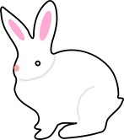
Part B. Making Connections

Use this Venn Diagram to compare and contrast “He Lion…” with The One and Only Ivan. Include the following elements in your diagram:

- Setting
- Characters
- Conflict
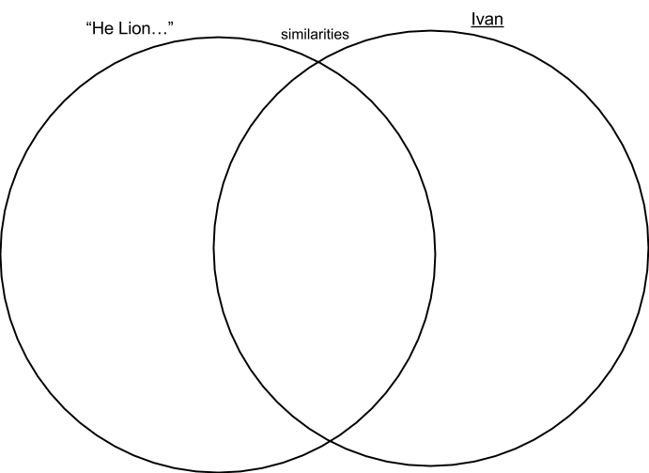
- Dialect
- Other

Extension Activity:
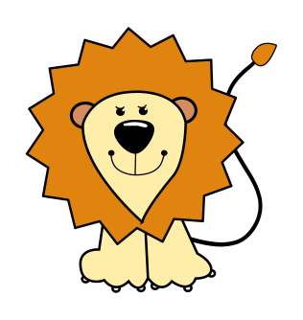
Use your knowledge of folk tale elements to write you own! Consider the following:
- Characters – Will your characters be animals or people?
- Setting – Where/when will your story be set?
- Theme or Moral – What will readers learn from your story?
- Literary Elements – Will you use personification, dialect, etc.?

