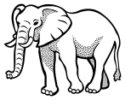
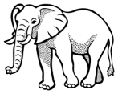
“When Animals Mourn” Name:

Concept Map and Questions: Use the information in the article to complete the concept map and short answer questions.
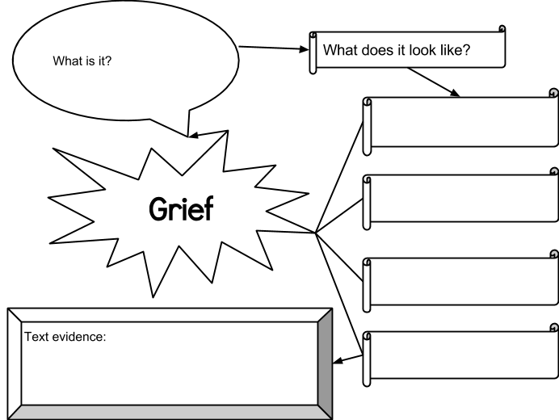

What are some examples from the text?

What are some synonyms of “grief?”

- According to the beginning of the article, what has Barbara King discovered about animals’ reaction to death?

- How does the story of Storm Warning seem to prove King’s ideas about animal grief?

- What piece of text evidence might you use to prove the following idea? Animals band together in difficult and distressing times.

- How do humans grieve? (What does it look like?) Is it different or similar to animal grief?

Words in Context: Find each of these challenging words in the “How Animals Mourn…” article (look for the bolded words). Fill out the chart below to determine the meaning.

Word | Context Clues  (Words and phrases, not whole sentences!) | Meaning
Skeptics
Matriarch
Cross-species

Ivan Connection:
What does it look like? Illustrate the scene:
Find an example of animals grieving in Ivan:
Page number: ____
Excerpt:

What positive change has Stella’s death caused within Ivan?

