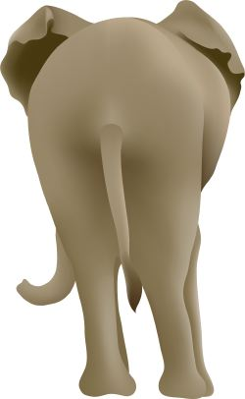
“How to Save a Baby Elephant” Name:
PART 1: “How to Save a Baby Elephant” Short Answer

- What threat to elephants is described in the first section? Why does this threat exist?

- Who first helped Ishanga? What challenges did they face?

- How did people at the Wildlife Trust help Ishanga? What do you think motivates them to help elephants?

- According to the article, in what ways do elephants seem similar to humans? Do you think poachers would kill elephants if they saw these similarities? Why or why not?

- How does “Ivory BUST!” help show that people both endanger and help protect elephants?

PART 2: Humans and Elephants

Mahatma Gandhi said, “The more helpless a creature, the more it is entitled to protection by man from the cruelty of man.” Fill in this graphic organizer to show how groups of people mentioned in the articles either offer protection to elephants or show cruelty to elephants.

Directions: For each group of people below, check one of the boxes, then use details from the articles to explain how those people either offer protection or show cruelty to elephants.

Keepers at the Sheldrick Wildlife Trust
Protect elephants Show cruelty to elephants

_____________________________________________________________________
_____________________________________________________________________
_____________________________________________________________________
_____________________________________________________________________
_____________________________________________________________________
_____________________________________________________________________

Members of the Task Force behind “Operation Lucky Dice”
Protect elephants Show cruelty to elephants

_____________________________________________________________________
_____________________________________________________________________
_____________________________________________________________________
_____________________________________________________________________
_____________________________________________________________________
_____________________________________________________________________
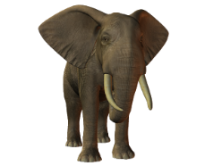
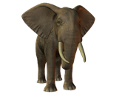
People who Sell Ivory
Protect elephants Show cruelty to elephants

_____________________________________________________________________
_____________________________________________________________________
_____________________________________________________________________
_____________________________________________________________________
_____________________________________________________________________
_____________________________________________________________________

PART 3: Making Connections

Think about what we have read, watched, and discussed this week in Language Arts. Consider what you learned at the Carolina Tiger Rescue. In what ways do people harm animals/wildlife? In what ways do people/organizations protect them?

Harm | Protect

