Station 2 Part 2 Is the Iditarod humane?
Alaska’s annual Iditarod Trail Sled Dog Race kicked off on Saturday in Anchorage with mushers and their dogs taking short runs through the city. The grueling 1,150-mile trek to Nome officially began on Sunday, with 67 mushers and more than 1,000 dogs competing — significantly fewer that last year, with some citing the expense of training as their reason for sitting this one out.

But this much-celebrated race is not without controversy.
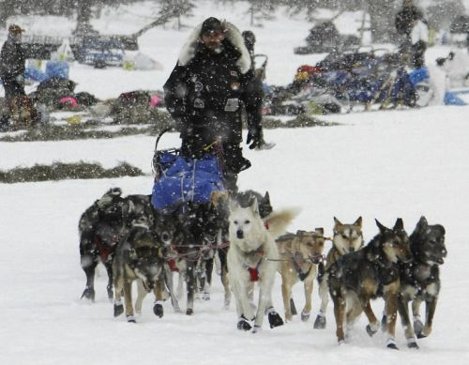
Defending Iditarod champion Lance Mackey.

According to a statement from the Humane Society of the United States(HSUS), mushing can be a wonderful way to exercise and bond with huskies. However, “the Iditarod’s extreme physical and psychological stress on the dogs and the dangerous conditions of the race have resulted in at least one canine death during nearly every Iditarod race, with some years’ death tolls reaching as many as five or six dogs.”
Animal rights groups, including PETA, have long protested the Iditarod, claiming that it is “marked by cruelty, injuries and death.” This year a PETA campaign urged sponsors to withdraw support from the event.

While the HSUS doesn’t object to all competitive mushing events, it does oppose the Iditarod in its current form, along with any other mushing events that place competition and entertainment ahead of the dogs’ safety and well being.
States the HSUS:
“The Iditarod forces the dogs to run too far and too fast in frequently grueling trail and weather conditions, and it exacts a severe, and sometimes fatal, toll on dogs’ physical and psychological systems. While the ITC has made some reforms in recent years, such as reducing the maximum size of dog teams from 20 to 16 for better musher control, organizers continue to mass-market the race and hype the competition among mushers who are continually attempting to break speed records.”

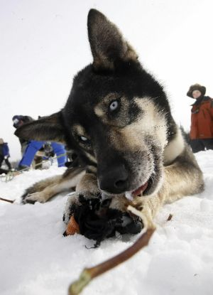
One of musher John Baker’s sled dogs chews on a boot during a rest at the Nikolai, Alaska, checkpoint.

Iditarod administrators have typically promoted the race as a commemoration of sled dogs being used to save the children of Nome by bringing diphtheria serum from Anchorage in 1925. However, the co-founder of the Iditarod, Dorothy Page, says 600 miles of this serum run was actually done by train and the other half was done by dogs running in relays, with no dog ever running more than 100 miles at a stretch.
Although there is no official count of dog deaths available for the race’s early years, at least 137 dogs are known to have died in the Iditarod, including six-year-old Viktor, a member of musher Jeff Holt’s team, who died on Tuesday.

Some sled dog race enthusiasts say that, for what is essentially an “ultra-marathon” event in extreme conditions for dogs, the overall percentage of deaths and injuries is relatively low, and because these are “working dogs” they are happy doing what they do best. In the words of one Baltimoresun.com reader: “They work to live and they live to work. That’s it. They are not Siberian Huskies, the are sled dogs. No sled, no dog.”

Margery Glickman, the director of Sled Dog Action Coalition and one of the race’s chief opponents, disagrees. “Iditarod dogs are prisoners of abuse,” she says. “It’s terribly wrong to anyone to promote this barbaric race. The Iditarod could not be legally held in many states because doing so would violate animal cruelty laws.” According to Glickman’s website, dog beatings and whippings are common. During the 2007 Iditarod, eyewitnesses reported that musher Ramy Brooks allegedly kicked, punched and beat his dogs with a ski pole and a chain. Glickman also notes that the race has led to the proliferation of overcrowded dog kennels where the dogs are treated inhumanely. “Many kennels have over 100 dogs, and some have as many as 200,” she says. “It is standard for the dogs to spend their entire lives outside tethered to metal chains that can be as short as four feet long. A dog who is permanently tethered is forced to urinate and defecate where he sleeps, which conflicts with his natural instinct to eliminate away from his living area.”
On the flip side, websites such as The Iditarod, Fact Not Fiction attempt to debunk many of the so-called myths hyped by Glickman and her Sled Dog Action Coalition.
What do you think: Should races like the Iditarod be outlawed? Is this event a legitimate form of entertainment for humans and dogs alike, or does it promote the inhumane treatment of animals?

