Station 3 Part 2
Is the Iditarod for the Dogs?
By Karen Fanning

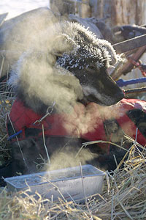
One of the dogs from Keith Aili's team during last year's Iditarod. Aili, of Ray, Minnesota, and his team were taking a break at the Nikolai, Alaska, checkpoint.
Photo: Al Grillo/AP Wide World
The Iditarod Trail Sled-Dog Race is a test of endurance and a battle against the elements. But too many dogs are failing the test and losing the battle, say animal-rights activists.
"Since 1973, there have been roughly 120 dog deaths," says Stephanie Shain, spokesperson for Humane Society of the United States (HSUS) in Washington, D.C.
Shain argues that the speeds at which dogs are forced to race lead to a variety of injuries, including pulled tendons, cut paws, dehydration, and heat stress.
According to the HSUS, during the past decade alone, dogs have died from heart failure, pneumonia, and sled accidents.
But three-time Iditarod champion Jeff King argues that he and his fellow mushers are well-trained and well-prepared to spot warning signs so that tragedies don’t happen.
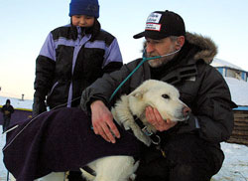
Hunter Solomon, 9, watches as veterinarian Dr. Ron Svec of Dummerstom, Vermont, checks out a sled dog at the Kaltag checkpoint during last year's Iditarod. (Al Grillo/AP Wide World)
“In the event a dog is injured or fatigued, our rules require, and basic dog care deems, that we give the dog a ride or we stop,” says the veteran musher. “The rules require that the sleds we use are capable of carrying a dog that is fatigued. We are all well-trained in dog first-aid. We carry a first-aid handbook, and we are members of organizations that make sure that we know what we are doing.”
During the race, the dogs require plenty of sleep. The Iditarod trail is a mushing marathon at 1,150 miles long—roughly equal to the distance between New York, New York, and Memphis, Tennessee.
While King plans to survive on four or five hours of sleep a day, his dogs will sleep six hours for every six hours they run. During layovers, he will spend most of his time tending to his dogs, feeding them, massaging and stretching their muscles, and inspecting their feet for injuries. Only dogs that are healthy enough will continue to race, he insists.
Today’s elite mushers polish off the Iditarod in roughly nine days, less than half the winning time of the first Iditarod in 1973. The Iditarod Trail Committee (ITC) attributes faster racing times to improved training, feeding, and veterinary practices. Shain has another explanation—mushers pushing their dogs harder and harder.
“We’re not opposed to mushing or even competitive mushing when the welfare of dogs is not sacrificed,” says Shain. “But every year, the goal is to run the race in a quicker time, and the dogs suffer because they are forced to run faster and faster. The race is the same length every year, but the time in which the dogs run the race continues to shrink.”
The ITC has reduced the size of dog teams from 20 to 16, which has given mushers more control. Still, there is more room for improvement, says Shain. She would like to see limits set on the distance and length of time dogs can run each day.
King disputes any allegations that mushers don’t have their dog’s best interest at heart. After all, you can’t win without a competitive dog team.
"Healthy dogs are fast dogs,” he says. “The key to someone who wants to win is knowing how to keep the dogs healthy and happy. They will not run fast if they are unhealthy or unhappy.”

