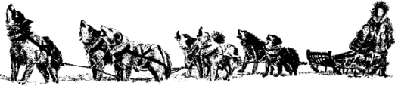
Name: _____________________________

Iditarod: Race Across Alaska
Stations Activity

What is the Iditarod?

- The Iditarod is an annual (yearly) ______________________. Racers travel over 1,850 kilometers from ___________________ to ______________.
- The race takes anywhere from ___________________ days.
- Each team consists of 12-16 _____________ and one ______________ (the person who guides the sled). The dogs are harnessed to the sled and pull the musher.
- The journey is challenging because of extreme _______________ like icy rivers, snow, mountain ranges, and wide expanses of frozen tundra.

Station #1: “The Race Against Death” Scholastic Scope Article
Directions: Read “The Race Against Death” and complete the graphic organizers below.
Text Feature: The titles, subheadings, photos, captions, charts, and maps in a nonfiction text that call attention to important details

In each bubble, describe one text feature from the article. Describe how that text feature helps the reader to better understand the text.

Directions: Find two pieces of text evidence to support each claim

Claim | Text Evidence #1 | Text Evidence #2
Sled dogs have heightened senses and physical attribute that make them particularly good at their jobs
Diptheria is a dangerous disease

Many people and animals worked together to help people in Nome survive

Station #2: Is the Iditarod Humane?

Vocabulary:
- Humane: kind or gentle to humans or animals
- Controversial: causing discussion, disagreement, or argument

Part One: Watch the video “Iditarod: A Tough Journey for Dogs” and answer the following question.

Why is the Iditarod controversial?

Part Two: Read the article “Is the Iditarod Safe for Dogs?” and complete the following chart using text evidence to support each position.

Face Off: Is the Iditarod Safe for Dogs?
YES  The Iditarod is safe for dogs | NO  The Iditarod is not safe for dogs

Part Three: Choose a side. Based on what you’ve read, answer the following question.

Is the Iditarod safe for dogs? Why or why not?

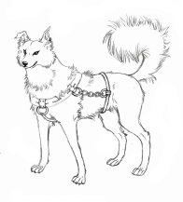

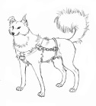
Station #3: Training for an Iditarod

Vocabulary:
- Infographic: A visual image such as a chart or diagram used to represent information or data

Part One: Look at the infographic “How to Train your Dog and Master for the Iditarod” and complete the following activity.

How do the dogs train for the Iditarod? | How does the musher train for the Iditarod?

