The Lunchroom Murder Name:

You are an investigator. A crime was committed, and it is your job to determine what may have happened.

Your Task: Look at the crime scene below, read the story, and develop a case to prove what happened.

Keep your eyes open for anything suspicious…
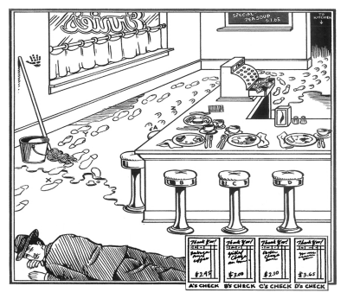

My observations:

On an otherwise uneventful Thursday afternoon police heard a shot inside Ernie’s Lunchroom, which is a popular diner in town. The police rushed in and found the scene above.
They identified the body as that of a well-known criminal named Joey. Ernie, who is both the owner and only employee, had only one fact to tell: the murderer had leaned against the wall while firing at point-blank range. The imprint of his hand is in clear view. The cash register has just been rung up at $8.75.
This is a difficult case. Your investigative team must attempt to determine which of the people in the lunchroom killed Joey. You will have to observe the details carefully. There is enough evidence to help you explain most of what happened. In working out the solution, turn the page to consider the following questions.

After reading the report, who do you think could have killed Joey?

Question | Evidence | Conclusion
What is interesting about the cash register? What does this tell you about the robbery?
What hand did the shooter use to fire the gun? How do you know?
How is customer C different from customers A, B, and D? (Hint: Look at the silverware)
Who do the footprints labeled “X” belong to? How do you know?

Which of the people in the lunchroom killed Joey?

