A. In the seventeenth century there was a civil war (a war between two sides of one country) in England between the Royalists, who supported the King and the Parliamentarians, who supported Parliament.
This famous nineteenth century painting by W. F. Yeames, shows a Royalist family who have been captured by the enemy. The boy is being questioned about the whereabouts of his father by a panel of Parliamentarians.
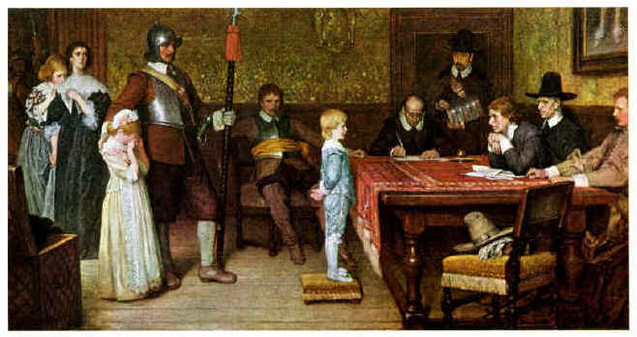
- Is this a primary or secondary source? How do you know?

- Why would this be a valuable resource?

- Is it reliable? Why or why not? Use evidence from the information above the picture!

B. Have a look at the picture below. It shows a steward's jacket that was recovered from the wreck of the Titanic and is now in the Titanic Museum in New York.
The Titanic, owned by the White Star Shipping Line, only made one journey and sank on the night of 15th April 1912.
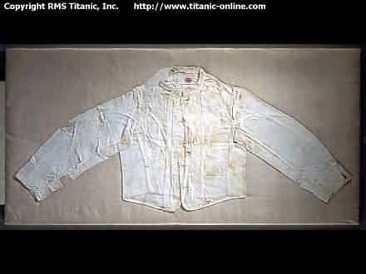
- Is this a primary or secondary source? How do you know?

- How does this artifact remain intact to this day?

- What do you think this source used for?

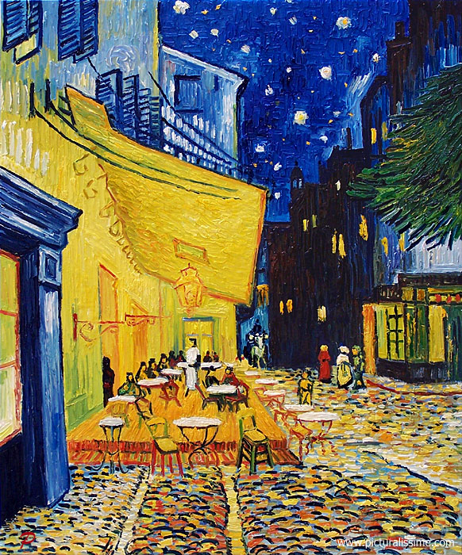
C. This is a poster print of a Van Gogh painting. Because people like Van Gogh paintings and because there is only one original painting, posters like this enable people to own and enjoy artwork.
Café Terrace at Night, also known as The Cafe Terrace on the Place du Forum, is a colored oil painting created in Arles, France, mid-September 1888. The painting is not signed, but described and mentioned by the artist in his letters on various occasions. There is also a large pen drawing of the composition which originates from the artist’s estate.

- Is this print a primary or secondary source? Explain your answer!

- What can people learn from a source like this one?

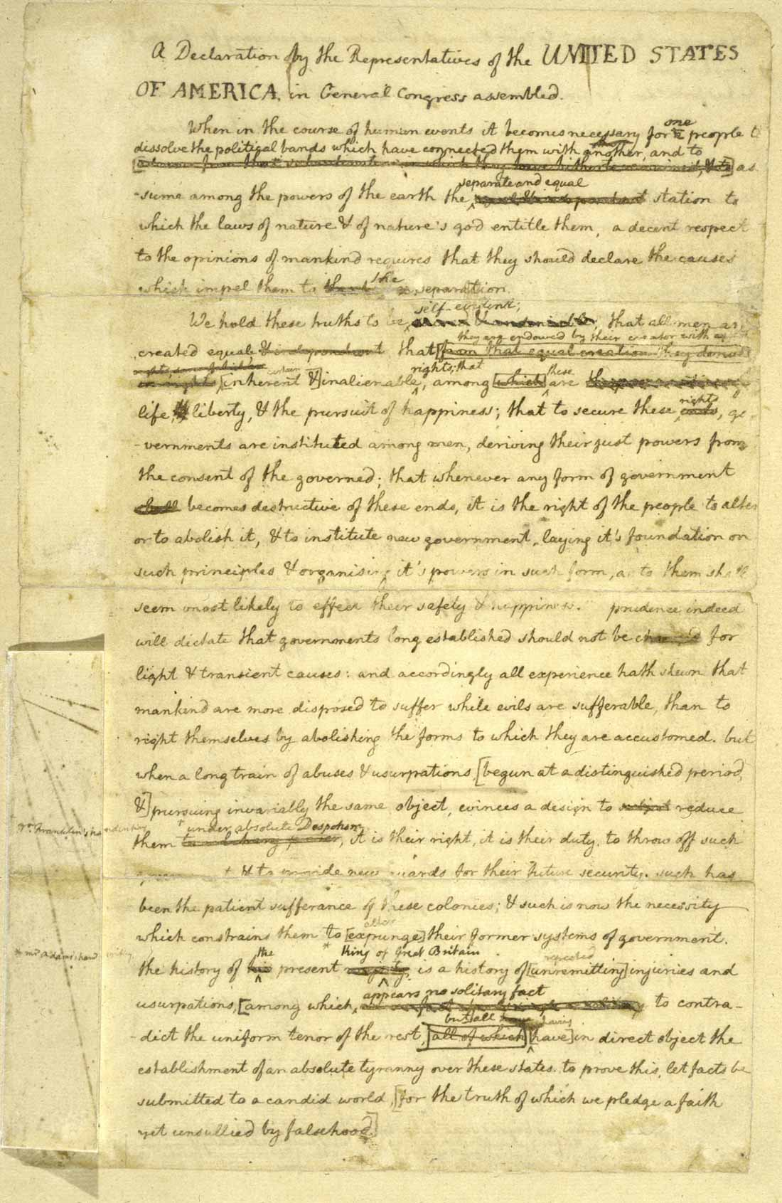

D. The original rough draft of the Declaration of Independence, one of the great milestones in American history, shows the evolution of the text from the initial "fair copy" draft by Thomas Jefferson to the final text adopted by Congress on the morning of July 4, 1776.
Of course Thomas Jefferson's handwritten draft of the Declaration of Independence is a treasure, not only because of its association with Jefferson but also because of what it reveals about how one of the founding documents of America was written and rewritten and finally agreed upon by dozens of men in the midst of a political crisis.

- Is this a primary or secondary source? How do you know?

- What do people use this source for? List as many possible uses as you can.

- What valuable information can people gain from this resource today?

E. In the 1860 presidential campaign, brightly colored banners, outrageous political cartoons, sentimental sheet music covers, and patriotic portraits were printed to win the vote. This bold campaign banner supports the candidacy of Abraham Lincoln during his first (and victorious) presidential campaign in 1860. The flag was meant to hang like a banner, so that Lincoln's face could be read vertically. The printer liberally changed the spelling of Lincoln's first name ("Abram") to accommodate his design.
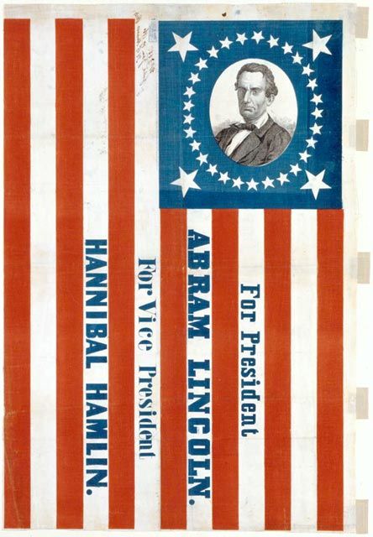
Imagine you are viewing the actual original campaign banner in a museum in Washington, DC.
- Is this a primary or secondary source? Explain how you know.

- Why would this source be displayed in a museum?

- Which do you think would be more valuable and reliable as a source – this banner or an excerpt in a Social Studies textbook about presidential campaigns during this time period?

F. The following excerpt was posted on the New York Times Learning Blog website. The topic of discussion was based on the pros and cons of homeschooling. Hannah, a college student who was homeschooled through high school, has expressed her opinion on the website.

November 15, 2011, 1:12 pm

I love how most people that have commented have bought into the argument that traditional schooling somehow mimics the real world, and that since you are homeschooled, you must be entirely cut off from this "real world experience." Even the social structure of traditional school isn't exactly reflective of adult life: as an adult, you don't hang out with people who are just your age, from the same district, and probably have a whole lot in common with you. It doesn't work that way as an adult; you have to interact with all sorts of people, not just the people the school district has assigned to your class. Having been homeschooled through high school and being in my third year at a great college in NYC, I can promise you I function in the real world just fine--as do 95% of the homeschoolers I know. ”
— Hannah
________________________________________________________________________________________________________________________

- Is this a primary or secondary source? Explain your answer!

- If you were writing a research paper on homeschooling, would this be a reliable resource to reference in your essay? Why or why not?

- Is The New York Times’ website “The Learning Network” a primary or secondary source? How do you know?

