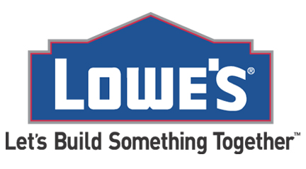   
 Lowe’s  
 1101 Beaver Creek Commons   
 (919) 303-4200

GST # 84334-7741 RT001  
Merchant ID: 1750000016083  
 -- SALE ----

Sales # S26742KS2 03-13-15  
  
182763261 Packing Boxes 12x12 1.99  
182763261 Packing Boxes 12x12 1.99  
182763261 Packing Boxes 30x30 1.99  
182763261 Packing Boxes 30x30 1.99  
182763261 Packing Boxes 30x30 2.99  
182763261 Packing Boxes 45x45 2.99  
762109992 Bubble Wrap 45x45 5.99  
128371238 Behr Paint sample 5.00  
192872187 Behr Paint sample 5.00  
655362511 Behr Primer 10.00  
998982889 Drop cloth 10.99  
473628871 50 piece tool set 75.60  
287387732 Large Paint brush 2.99  
287832718 Ladder 10ft 50.75  
592821891 Screen Door 119.00  
387923723 Rake 10.75  
587232783 Yard Sale Sign 1.00  
587232783 Yard Sale Sign 1.00  
587232783 Yard Sale Sign 1.00  
326325365 Hand Shovel 15.00  
099289792 Garden Center: Daffodils 6.99  
099289792 Garden Center: Daffodils 6.99  
099289792 Garden Center: Daffodils 6.99  
099289792 Garden Center: Daffodils 6.99  
 Subtotal 355.97  
 Tax 14.23  
 Total 370.20  
 Gift Card 200.00  
 Balance Due 170.20  
 # of items Purchased 24  
 Thank You for shopping at Lowe’s   
 www.lowes.ca/feedback  
 Store Code: 280891-2188113

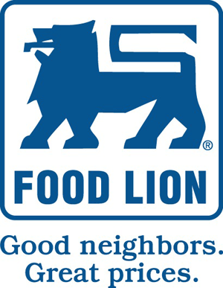

#1383 STORE PHONE (919) 686-2492  
 Thank You! Sales Associate: Hannah P.

Pillsbury Yellow Cake Mix 2.99  
 Pillsbury Chocolate Frosting 2.99  
 Sprinkles 1.59  
 12 pack candles .99  
 3 @ .99 Coke 32 ounce 2.97  
3 @ .99 Mountain Dew 32 ounce 2.97  
2 @ .99 Sprite 1.98  
 Breyers Vanilla Ice Cream 4.99-  
 MVP Price 2.50  
 Breyers Chocolate Ice Cream 4.99-  
 MVP Price 2.50  
3 @ 2.00 Mozzarella Shredded Cheese 6.00  
2 @ 1. 00 Pizza Sauce 2.00  
 Sliced Pepperoni 1.50  
3 @ 1.00 Pizza Dough 3.00  
2 @ .50 Plastic table cloth (red) 1.00  
3 @ 2.99 Variety pack balloons 8.97  
 Purina Multi-cat dry chow 11.78-   
 MVP Price 9.00   
 Gerber Baby, Carrots and Peas 3.00-  
 MVP Price 1.75  
 Gerber Baby, Applesauce 3.00-  
 MVP Price 1.75  
 Gerber Baby, Summer vegetables 3.00-  
 MVP Price 1.75  
 Pampers, 34 count diapers 37. 94-  
 MVP Price 25.00

Total 82.70  
 Tax 3.30  
 Balance Due 86.00  
 CASH 100.00   
 Change 14.00  
 Coupons tendered 0

Total items purchased 32  
4/25/15 8:30 am

[www.foodlion.com](http://www.foodlion.com)  
 Customer Service 1-800-210-9569

MVP Customer 46144064871 You are a valid MVP Customer   
 **YOU SAVED $25.95 using your MVP CARD**



Save Money. Live Better   
OFF! Bug Repellent 23900198118 3.99   
Marshmallows 80298210229 1.99  
Adult gloves 69000292221 2.00  
Tea Kettle 01192007188 5.00   
Large Pot 28772110992 8.00  
Weather resistant tarp 21319853010 5.00   
Honeymaid Graham Crackers 41119860280 2.99  
Hersey Chocolate 6 pack 92276923827 4.99  
Firewood starter logs 10923897321 10.99  
Air mattress twin size 09291950292 25.00  
Jack Links Beef Jerky Original 90282791871 4.85  
Realtree Men’s Micro Fleece 10062871272 14.00   
Doritos Nacho Cheese 23727302936 2.75 x 2  
Gala Apple 87812376176 .50 x 6  
Walls Men’s Insulted Hooded Jacket 39872127123 49.96   
Swiss Miss Hot chocolate Mix 199978172872 1.75  
Beneful Adult Dog Food 000929781272 27.19   
Purified water bottles 25 count 276098718787 2.89  
Mesh Bag 987278711127 1.99 x 3  
Ziplock bags 001298376111 3.99   
Fruit of the Loom Value Pack Long johns 76382737 10.00   
Ozark Trail Sleeping bag 8555342725210 30.47  
Hot Hands heat warmers Value pack 12867236889 6.00   
Trail Mix 0928178627719 1.99 x4  
Dish towel 39908828170001 .50 x2  
Igloo 52 quart Cooler 86127611108990 39.99   
Ballpark Franks 88837236266662 3.99  
Hotdog Buns 53552755872885 2.00   
Blanket 14269200021311 5.75 x3  
 Subtotal 307.71  
 Tax 12.30  
 Total 320.01  
 Account # 09822727   
 CHANGE DUE 0.00

# ITEMS SOLD 37   


We gladly accept valid manufacturer and internet coupons   
 11/06/14 14:56: 29  
******************Customer Copy *********************



4/25/15 8:06 am  
 RETURN BEFORE 7/25/15



GIVING A GIFT? Include a gift receipt! A receipt dated within 90 days is required for all returns and exchanges.

**GROCERY**   
056509043 Goldfish Crackers $3.99  
1087150011 Beneful Adult Dog food $27.19  
 MF Coupon $5.00 -  
003719034 Bunch of bananas $2.59  
5490126780 Lipton Naturals $3.00  
 2 for $1  
**HEALTH-BEAUTY**  
311609421 OPI nail polish $5.19  
15098006 Coppertone Sunscreen $9.98  
 2 @ $4.99  
**APPAREL**   
600918791 Women’s sandals $10.00  
910162901 Men’s board shorts $29. 99  
5003387202 Women’s 1 piece swimwear $19.99  
007122986 Jr’s swimwear $15.00  
**HOME**  
700361811 Coleman 52quart Extreme Cooler $39.99  
194877233 Blanket $5.99  
4209144688 Beach chairs $30.00  
 3 @ $10.00  
**SPECIALITY**   
097661009 Apple Itunes Gift Card $30.00

Subtotal $227.90  
 Your REDcard savings 5% $11.39  
 Tax $8.66  
 Total $225. 17

***** -******* 3870002 Target Card charged