Slip or Trip? Name:

You are an investigative team. A crime was committed, and it is your job to determine what may have happened.

Your Task: Look at the crime scene below, read the story, and develop a case to prove what happened.

Keep your eyes open for anything suspicious…
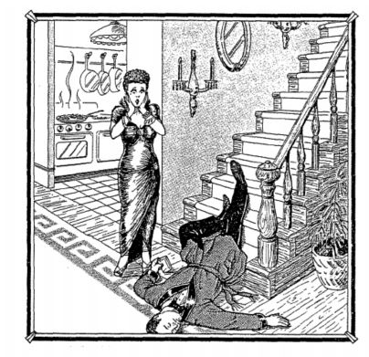

My observations:

Five feet tall and hundred and ten pounds, Queenie was a delicate, beautiful woman. When she tore out of the house after an argument with her husband, Arthur, she went to her Mother’s house for support and comfort.
Queenie arrived back at her home at 9 o’clock in the evening. Upon arriving, she called some of her friends and invited them over to have a girl’s night in. Queenie’s friends arrived at her house about twenty minutes after Queenie, who met them at the door and said, “Something terrible happened. Arthur slipped and fell on the stairs. He was coming down for a glass of water- he still had the water glass in his hand- I think he’s dead. Oh my God! What shall I do?”
The autopsy conducted later concluded that Arthur had died from a wound on the head and that there were suspicious toxins found in his system.

Answer the following questions to build an argument about what YOU think happened to Arthur!

- In your opinion, how did Arthur die?

- Do you believe what Queenie says? Why or why not?

- From whose point of view is the story told? Why is this important to the story?

Evidence | Prior Knowledge | Conclusion
What was Arthur holding?
___________________
___________________
___________________
___________________
___________________
What do you notice about the items on the wall?
___________________
___________________
___________________
___________________
___________________  ___________________  ___________________  ___________________  ___________________ |  | If Queenie is guilty, she could not have killed her husband with force.
What did the autopsy report find?
___________________
___________________
___________________
___________________

Directions: Use the chart below to build an argument around the story.

What is your final conclusion about Queenie’s story?

