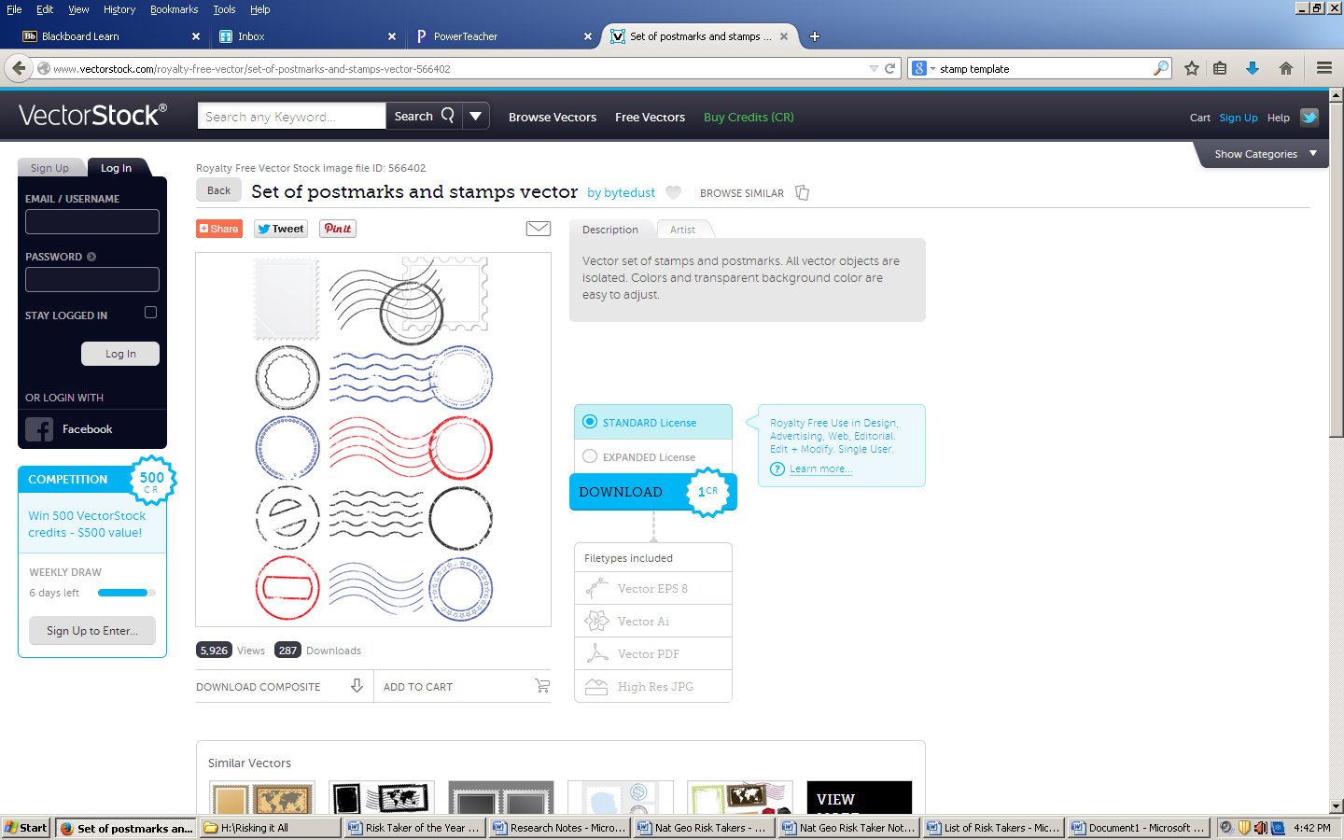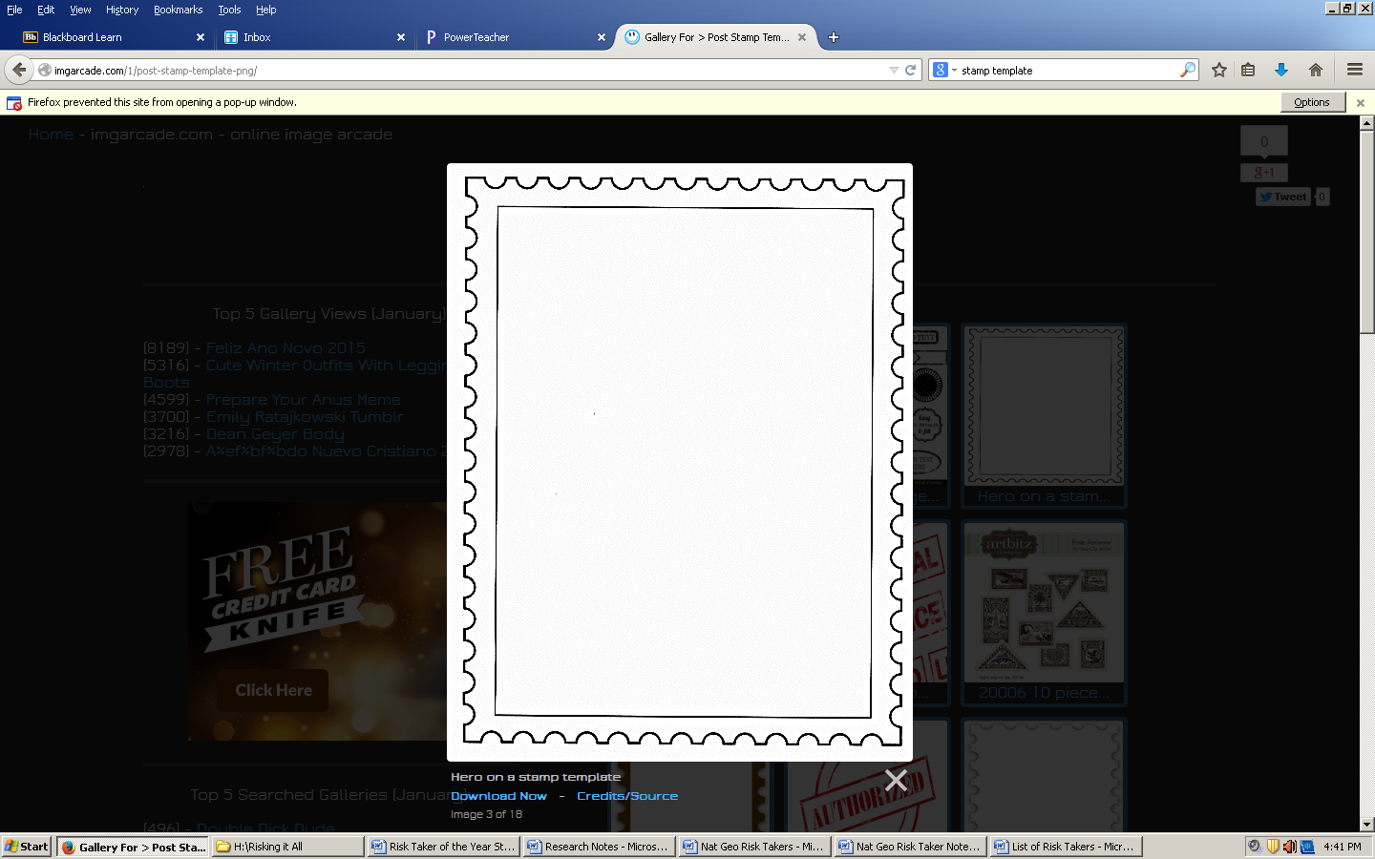**Name: _____________________________**