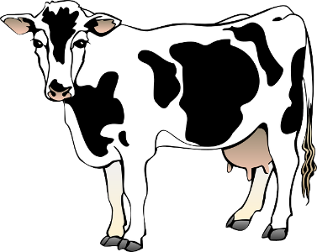
“The Stone” by Lloyd Alexander

Pre-Reading:
Vocab Chart
Codger (868): an older fellow.  Rue (p.871): regret.  Wretch (p. 871): someone who causes trouble and is annoying.  Vainly (p. 873): unsuccessfully. | Belabored (p. 874): to hit repeatedly.  Avail (p. 874): benefit.  Mired (p. 874): stuck.  Laden (p. 875): weighted down.

Prediction Chart
What’s your prediction? | Text evidence. | What happened in the story? | Was your prediction correct?
#1
#2
#3

Post-Reading:
- How does Maibon get the stone?

- How does the stone cause problems for Maibon, his family, and his farm?

- What happens when Maibon tries to throw the stone?

- Why can’t Maibon get rid of the stone?

- What is the climax, or turning point of the story?

- Choose a word from the story that you do not know. Use context clues to define that word.

- Characterize Maibon. In other words, what are his character traits? Does his character change in the story? Why or why not?

- Many advertisements promote youthfulness. Do you think this is a good message? Why or why not?

- How is the wife’s reaction to Maibon’s wish similar to or different from the woodsman’s reaction in “The Three Wishes?”

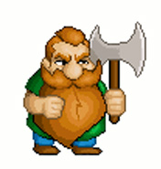

- Would you have given up the stone? Explain.

