The Structure of the Earth and Plate Tectonics
The Earth’s Crust
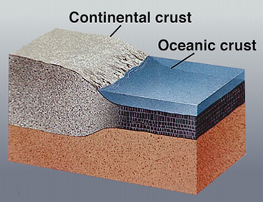
- This is where we ________!
- The Earth’s crust is made of:
Continental Crust
- __________ (10-70km)
- buoyant (less ________ than oceanic crust)
- mostly _________
Oceanic Crust
- __________ (~7 km)
- _________ (sinks under continental crust)
-_________
What is Plate Tectonics?
- If you look at a map of the world, you may notice that some of the continents could fit together like_________ of a ____________.
- The Earth’s crust is divided into _________major_______ which are moved in various directions.
- This plate ________ causes them to _______, pull ______, or ________ against each other.
- Each type of ____________ causes a characteristic set of Earth structures or “tectonic” features.
- The word, _______, refers to the deformation of the crust as a consequence of ____ interaction.
What are tectonic plates made of?
- Plates are made of rigid ____________.
- The lithosphere is made up of the _______ and the upper part of the _________.
What lies beneath the tectonic plates?
- Below the lithosphere (which makes up the tectonic plates) is the ______________.
Plate Movement
- “Plates” of lithosphere are moved around by the underlying hot ________ convection cells
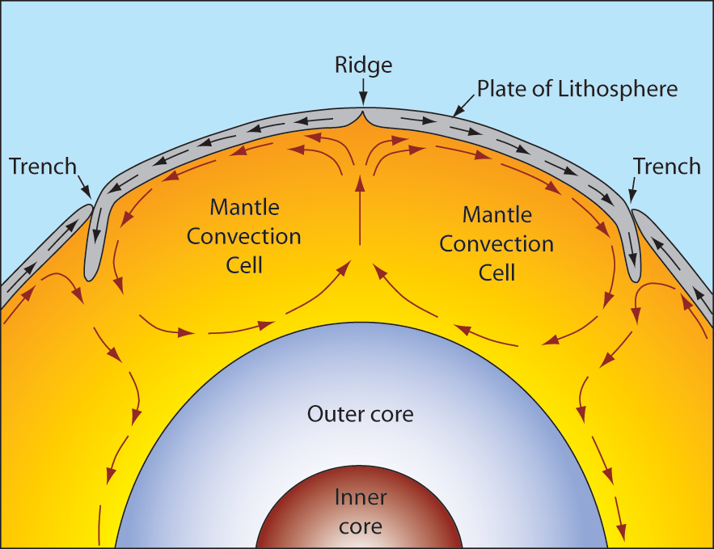
What happens at tectonic plate boundaries?
________ types of plate boundaries
- Divergent 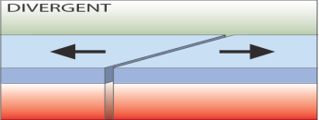
- Convergent 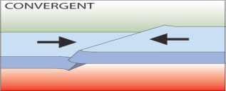
- Transform 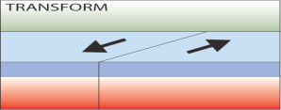
Divergent Boundaries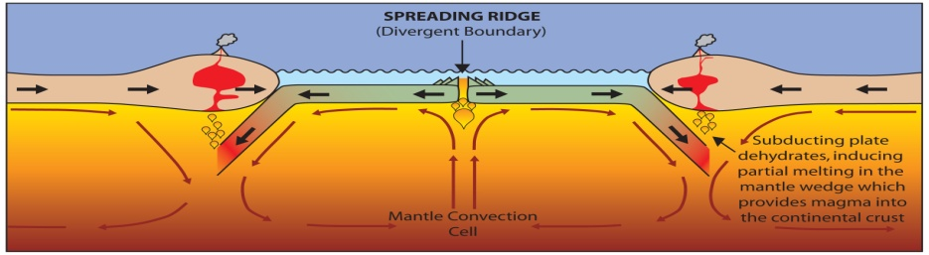
- Spreading ________
As plates move apart new material is _________ to fill the gap

Convergent Boundaries
- There are _________ styles of convergent plate boundaries
  - Continent-________ collision
  - Continent-_______ crust collision
  - Ocean-______ collision
- Continent-Continent Collision
- Forms ________, e.g. European Alps, Himalayas
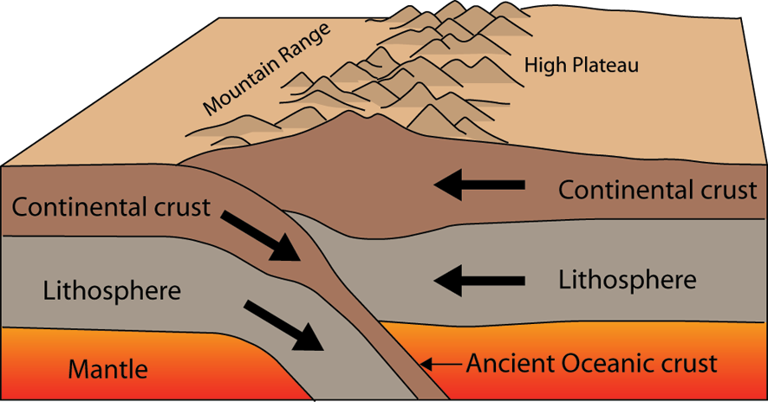

Continent-Oceanic Crust Collision
- Subduction: At a __________ boundary where continental ________ pushes against _______ crust, the oceanic crust which is thinner and more _____ than the continental crust, _______ below the continental crust.
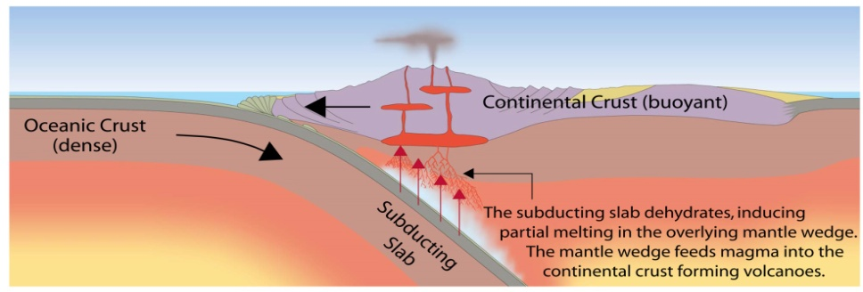
Subduction
- Oceanic lithosphere subducts _________ the _________l lithosphere
- Oceanic lithosphere _______ and dehydrates as it subsides
- The __________ rises forming volcanism or a volcano
- E.g. The Andes
Ocean-Ocean Plate Collision
- When two _________ plates collide, one runs over the other which causes it to ____ into the _________ forming a subduction ____________.
- The subducting plate is ________ downward to form a very deep depression in the ocean floor called a __________.
- The world’s__________ parts of the ocean are found along trenches.
  - E.g. The Mariana Trench is 11 km deep!

Transform Boundaries
- Where plates _______ past each other
Volcanoes and Plate Tectonics…
What’s the connection?
Pacific Ring of Fire
Volcanism is mostly focused at ________ margins
Volcanoes are formed by:
Subduction - Rifting - Hotspots
The tectonic plate ______ over a fixed _______ forming a chain of volcanoes.
Earthquakes and Plate Tectonics…
What’s the connection?
- As with volcanoes, earthquakes are not __________ distributed over the globe
- At the boundaries between plates, _________ causes them to stick together. When built up ___________ causes them to break, __________ occur.
Where do earthquakes form?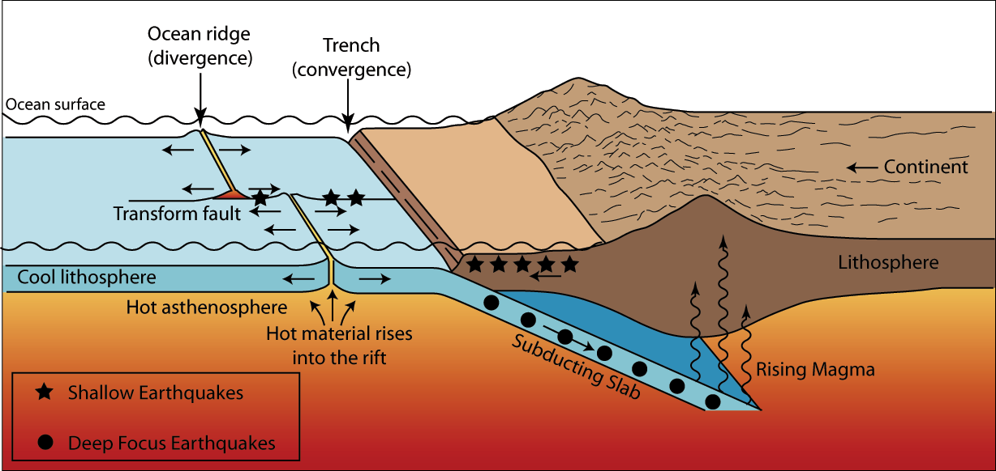
Plate Tectonics Summary
- The Earth is made up of ___ main layers (core, _______, crust)
- On the surface of the Earth are __________ plates that slowly _______ around the globe
- Plates are made of ________ and upper _______ (lithosphere)
- There are_____2 types of plates
- There are _______ types of plate boundaries
- Volcanoes and __________ are closely linked to the margins (edges) of the ________ plates

