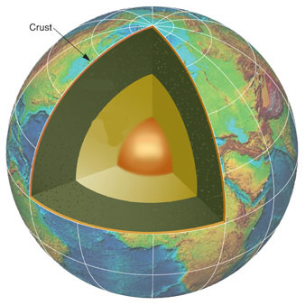Bill Nye The Science Guy

Earth’s Crust

***\*\*Circle or fill in the blank to correctly complete the sentences below\*\****

1. Bill Nye The Science Guy, “Earth’s Crust” is

brought to you by ______________________.

1. You and I live on the Earth’s

( **crust, mantle, core** ) a thin layer of solid

rock that’s all around the Earth.

1. The core is solid ( **dirt, ice, iron** ).
2. Earth’s core is around ( **500, 1500, 5000** ) degrees Celsius.
3. Earth’s mantle is around ( **2000, 1000, 1200** ) degrees Celsius.
4. Volcanoes give us a ___________________________ to what’s underneath the Earth’s crust.
5. Scientists believe that Earth’s crust is made of tectonic _____________________________.
6. The plates are floating on the Earth’s ( **crust, mantle, core** ).
7. Scientists believed that at one time all the plates of the Earth’s crust were one piece called

________________________________.

1. Where the tectonic plates are spreading apart we get ( **volcanoes, lakes, mountains** ).
2. Where the plates are coming together we get ( **volcanoes, lakes, mountains** ).
3. North America is moving away from Europe at about _______________________ every year.
4. Shifting tectonic plates cause ____________________________________.
5. Earth’s core is about ( **1200, 2800, 3600** ) km. across.
6. Earth’s __________________ is the thinnest part of the planet.