Narrative Book Jacket
For the narrative that you have written, fold a sheet of blank white paper to create a book jacket including all of the following information:
Front Cover
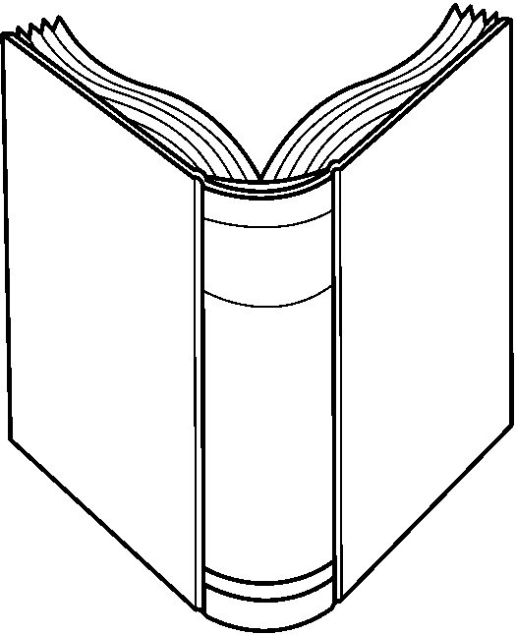
Title, Author, Picture/Illustration (COLOR), Awards
Back Cover
Title, Author, Picture/Illustration (Color)
Spine
Title, Author, Symbol for Book
Front Flap
Excerpt from book, Summary, Details of Awards Won
Back Flap
Biography of Author, Picture/Illustration for Book or Author

Narrative Book Jacket
For the narrative that you have written, fold a sheet of blank white paper to create a book jacket including all of the following information:
Front Cover
Title, Author, Picture/Illustration (COLOR), Awards
Back Cover
Title, Author, Picture/Illustration (Color)
Spine
Title, Author, Symbol for Book
Front Flap
Excerpt from book, Summary, Details of Awards Won
Back Flap
Biography of Author, Picture/Illustration for Book or Author

