Name: _______________________________ Date: _____________________

Distance Between Points

Use the graph below to help solve the following problems.
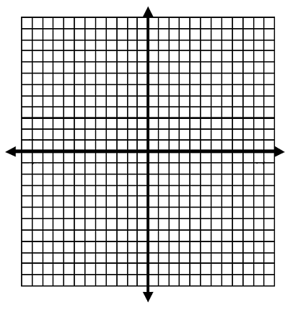

Find the distance between the following points:

- (4, 6) and (4, -8)

- (10, -7) and (10, 5)

- (-9, 6) and (6, 6)

- (-6, 5) and (-3, 5)

Find the distance without using the graph.
- (9, 7) and (9, -2)

- (-6, 3) and (-10, 3)

- (8, $-4\frac{1}{3}$) and (8, 3$\frac{1}{4}$)

- (7$\frac{2}{3}$, 4) and (-6$\frac{1}{4}$, 4)

- Tammy started at home at (4, 5) and then went to the store at (4, 1). She decided to then stop for gas at (4, -4) and then to pick up her printed photos at (4, -5). She then went home. What was Tammy’s total distance?

