Who is Edgar Allan Poe?

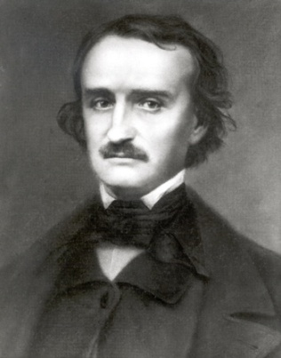
The name Poe brings to mind images of murderers and madmen, premature burials, and mysterious women who return from the dead. His works have been in print since 1827 and include such literary classics as “The Tell-Tale Heart” and “The Raven.” This versatile writer’s work includes short stories, poetry, a novel, a textbook, a book of scientific theory, and hundreds of essays and book reviews. He is widely acknowledged as the inventor of the modern detective story and an innovator in the science fiction genre, but he made his living as America’s first great literary critic. Poe’s reputation today rests primarily on his tales of terror as well as on his haunting lyric poetry.
Just as the bizarre characters in Poe’s stories have captured the public imagination so too has Poe himself. He is seen as a morbid, mysterious figure lurking in the shadows of moonlit cemeteries or crumbling castles. This is the Poe of legend. But much of what we know about Poe is wrong, the product of a biography written by one of his enemies in an attempt to insult the author’s name.
The real Poe was born to traveling actors in Boston on January 19, 1809. Within three years of Poe’s birth both of his parents had died, and he was taken in by the wealthy tobacco merchant John Allan and his wife Frances Valentine Allan in Richmond, Virginia. Mr. Allan would help Poe to become a businessman and a Virginia gentleman, but Poe had dreams of being a writer in imitation of his childhood hero the British poet Lord Byron. By the age of thirteen, Poe had compiled enough poetry to publish a book, but his headmaster advised Allan against allowing this.
In 1826 Poe left Richmond to attend the University of Virginia, where he excelled in his classes while collecting significant debt. The stingy Allan had sent Poe to college with less than a third of the money he needed, and Poe soon took up gambling to raise money to pay his expenses. By the end of his first term Poe was so desperately poor that he burned his furniture to keep warm.
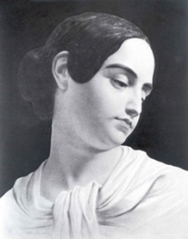
Humiliated by his poverty and furious with his father, Poe returned to Richmond and visited his fiancée Elmira Royster, only to discover that she had become engaged to another man in Poe’s absence. The heartbroken Poe’s last few months in the Allan mansion were punctuated with increasing anger towards Allan until Poe finally stormed out of the home to become a great poet and to find adventure. He went on to publish his first book when he was only eighteen, and he enlisted in the United States Army.
Two years later he heard that Frances Allan, the only mother he had ever known, was dying of tuberculosis. By the time Poe returned to Richmond she had already been buried. Poe and Allan briefly reconciled, and Allan helped Poe gain an appointment to the United States Military Academy at West Point.
Before going to West Point, Poe published another volume of poetry. While there, Poe was offended to hear that Allan had remarried without telling him or even inviting him to the ceremony. Poe wrote to Allan detailing all the wrongs Allan had committed against him and threatened to get himself expelled from the academy. After only eight months at West Point Poe was thrown out, but he soon published yet another book.
Broke and alone, Poe turned to Baltimore, his father’s home, and called upon relatives. Poe’s aunt, Maria Clemm, became a new mother to him and welcomed him into her home. Clemm’s daughter Virginia first acted as a messenger to carry letters to Poe’s lady loves but soon became the object of his desire.
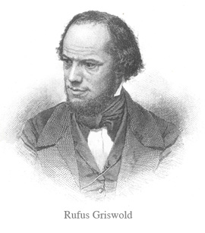
While Poe was in Baltimore, Allan died, leaving Poe out of his will. By then Poe was living in poverty but had started publishing his short stories. He eventually gained an editorial position at the Southern Literary Messenger in Richmond. Within a year Poe helped make the Messenger the most popular magazine in the south with his sensational stories as well as with his scathing book reviews. Poe soon developed a reputation as a fearless critic who not only attacked an author’s work but also insulted the author and the northern literary establishment.
At the age of twenty-seven, Poe brought Maria and Virginia Clemm to Richmond and married his Virginia, who was not yet fourteen. The marriage proved a happy one, and the family is said to have enjoyed singing together at night.
In the wake of a financial crisis Poe struggled to find magazine work. In the face of poverty Poe was still able to find solace at home with his wife and mother-in-law, but tragedy struck in 1842 when Poe’s wife contracted tuberculosis, the disease that had already claimed Poe’s mother, brother, and foster mother.
The January 1845 publication of “The Raven” made Poe a household name. He was now famous enough to draw large crowds to his lectures. At this time he moved to a tiny cottage in the country. It was there, in the winter of 1847 that Virginia died at the age of twenty-four. Poe was devastated. His critics assumed he would soon be dead. They were right. Poe only lived another two years.
He was found in a bar room that was being used as a polling place for an election. A magazine editor sent Poe to a hospital, where Poe spent the last days of his life far from home and surrounded by strangers. Poe’s mother-in-law did not know what had become of him until she read about it in the newspapers. Poe died on October 7, 1849 at the age of forty. The exact cause of Poe’s death remains a mystery.
Days after Poe’s death, his literary rival Rufus Griswold wrote an insulting obituary of the author in a misguided attempt at revenge for some of the offensive things Poe had said and written about him. He portrayed Poe as a drunken, madman with no morals and no friends. Griswold’s attacks were meant to cause the public to dismiss Poe and his works, but the biography had exactly the opposite effect and instead drove the sales of Poe’s books higher than they had ever been during the author’s lifetime. Griswold’s misleading image of Poe created the Poe legend that lives to this day.
http://www.poemuseum.org/life.php

Versatile: able to adapt or be adapted to many different functions or activities.
Innovator: a person who introduces new methods, ideas, or products.
Punctuated: occur at intervals throughout (a continuing event or a place).
Solace: comfort or consolation in a time of distress or sadness.

