Name __________________________ Date_____________________

Earth’s Tilt
What is tilting?
- The earth is tilted on its axis _______ degrees.

How does the earth move?
- Rotation – one complete turn on earth’s axis.
-
- Revolution – one complete orbit of the earth around the sun.
-

What causes day & night?
- As earth rotates on its axis, it turns towards and away from the sun.
- _________________ is when your half of the earth is facing the sun.
- _________________ is when your half of the earth is turned away from the sun.

Why are there time zones?
- As earth moves, different parts of the earth receive ______________________ at different times.
- This is why there are different __________________________around the world.
- In the US, the east coast turns towards the sun _________________.
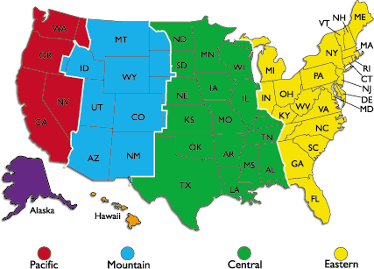

Think, Pair, Share:
- How would you explain a sunset?
- How much of the earth experiences daylight at any given time?
- Is the earth in the center of the universe?
- Why do some places on earth receive 6 months of daylight and then 6 months of nightime?
- What is the purpose of a leap year?

Why are there seasons?
- It takes Earth ________________________ to orbit around the sun.
- As Earth __________, it is tilted at different angles towards/away from the sun.
- Summer is warmer than winter (in each hemisphere) because the Sun's rays hit the Earth at a more ____________________ during summer than during winter.

Equinox
- “_________________________”
- Sunlight hits the earth most directly at the _____________.
- Day & night lasts _____________ hours at all latitudes.
- Spring & Fall

Solstice
- A Solstice occurs twice a year, when the tilt of the Earth's axis is tilted directly towards or away from the Sun, causing the Sun to appear to reach its northernmost and southernmost _________________________.
- Winter solstice is the shortest day of the year. In the Northern Hemisphere. It occurs on __________________________ and marks the beginning of winter.
- The Summer Solstice is the longest day of the year. It occurs on ______________ and marks the beginning of summer.

Think, Pair, Share:
- If it’s winter in the Southern Hemisphere, what season will it be in the Northern Hemisphere?
- How is it possible for us to be out on break and go to the beach and students in Australia to be out on break and go skiing?
- What is a solstice? When do they occur?
- What is an equinox? When do they occur?

