Growing and Flowing Scavenger Hunt
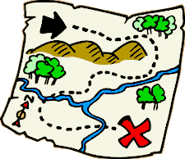
You will take a journey through the Apex Middle School campus! On this journey you will need to stay with your lab group. As a class we will explore the world around us. While we are exploring be sure to record all findings and observations that you notice.
Object | Description of Object | Drawing of Object
Pollen
Pollinator
Angiosperm
Gymnosperm
Stem
Leaf
Root
Petals
Stigma
Style
Anther
Filament
Germination
Tropism
Transpiration
Biotic Factor
Abiotic Factor
Decomposer
Consumer
Producer

Where would photosynthesis occur in the plant you observed?

How would the plant you observed defend itself?

In what part of the plant did transpiration occur? Describe this process including what is entering and exiting the plant.

Gather a sample of one object from the chart. Why did you choose this object?

Tape object here.

