Ivan Guide #1 (p. 1-105) Name:
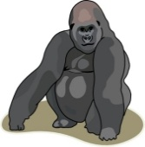
Amid (p. 6): surrounded by  Beckons (p. 8): signals; directs  Wily (p. 34): sly  Undaunted (p. 37): fearless | To make amends (p. 64): to make up for a wrong-doing  Homo sapiens (p. 104): scientific name for human beings

- From which point of view is the novel narrated? Check one below:

___ 1st person: The narrator is a character in the story who uses the pronouns I, me, my
___ 2nd person: The narrator refers to the reader using the pronoun you
___ 3rd person: A narrator outside of the story who uses the pronouns he, she, they

Who is the narrator? ________________________

- Does Ivan think that humans understand gorillas? Explain in your own words and provide text evidence (an excerpt/quote) to support your answer.

- Describe Ivan’s domain.

- What does Ivan say about anger? Why doesn’t he express anger at the beginning of the novel?

- To what does Ivan compare his “circus” on page 13? What can you infer about the circus based on this comparison?

- Why do people pay for Ivan’s drawings even if they don’t recognize what he has drawn?

- Why is Ivan’s art important to Mack? To Julia?

- Describe Bob. How did he come to live at Big Top Mall? How is he different from other dogs?

- Describe the relationship between Julia and Ivan. How is she different from all the other children that come to see Ivan and his shows?

- What does Stella do when Ruby arrives at Big Top Mall? Why does she act this way?

- What happened to Ruby’s mom, aunts, sisters, and cousins? What does this tell you about some humans’ treatment of animals?

- Why does George tell Mack to take a look at Stella’s foot in the chapter titled “Treat?” What is Mack’s response? Why does he respond this way?

- How did Ruby get out of the big hole after she fell in while looking for food with her family? What does this tell you about some humans’ treatment of animals?

- On page 104 Stella says, “Humans can surprise you sometimes. An unpredictable species…” What do you suppose she means by that?

Character Map: As you read, fill in boxes 1-4 below. Next, write character traits that describe Ivan based on your findings.

1. What Ivan feels:  IVAN | 2. What other characters think about Ivan:
3. What Ivan does: | 4. What Ivan says:

Ivan’s Character Traits (based on your findings in the character map above):

- _________________________

- _________________________

Venn Diagram: A Venn diagram is used to compare (similarities) and contrast (differences) a topic or idea. Use the diagram below to compare and contrast Ivan and Stella based on your reading so far. You must focus your comparisons on the categories listed beside the diagram.
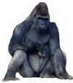

COMPARISON CATEGORIES

A. Physical Characteristics

B. Memory

C. Relationship with Ruby

D. Health

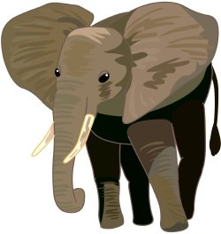
E. Other

