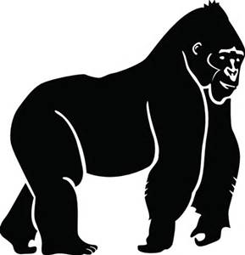
The One and Only Ivan Pre-reading Guide Name:

PART 1: Making Predictions – Good readers skim the text before they read. They make predictions about what the text will be about and what will happen in the story. Follow the directions below to make predictions about The One and Only Ivan.

Directions | Make a Prediction | What is your prediction based on?
Look at the front cover.
Look at the important words from the novel below.

Skim the novel, choose a chapter title, and copy the title below:

“_________________________”
Finally, read the back cover (paperback book) or the inside front cover (hardback book).

PART 2: Writing Prompt – Respond to one of the prompts below in paragraph form on a separate sheet of paper. In your response, you should state an opinion and include at least two reasons why you think this. Include as many details as possible.

Prompt A  - Have you ever been to a circus or seen a circus on television/movies?  - When watching the animals and their trainers, what did you observe?  - How were the animals treated?  - Do you think it’s okay to keep animals in circuses | Prompt B  - Have you ever been to a zoo?  - When watching the animals and their caretakers, what did you observe?  - How were the animals treated?  - What purpose(s) do zoos serve?
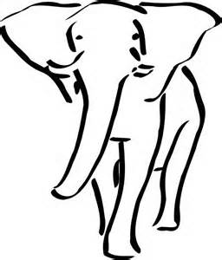
PART 3: Forming an Opinion – Read the statement in the chart, and put a check mark in the “Agree” or “Disagree” column. Explain why you agree or disagree in the “Before Reading” column.
*When you finish The One and Only Ivan, you will revisit your responses and fill out the “After Reading” column.

Statement | Agree | Disagree | Before Reading – Explain your response. | After Reading – Has your opinion changed or remained the same? Explain using text evidence from the novel.
Animals should not ever be controlled by humans.
Animals have feelings/emotions just like humans.
For the most part, animals are treated well by humans.
You should always forgive someone who treats you poorly.
A negative experience is worthwhile if you learn something from it.

