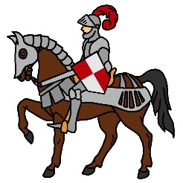
MIDDLE AGES holiday WEBQUEST
Directions: Use either your device or classroom laptop to complete this activity!

Part 1: Visit the following webpage: http://medievaleurope.mrdonn.org/holidays.html

- Read the article
- Answer the following questions
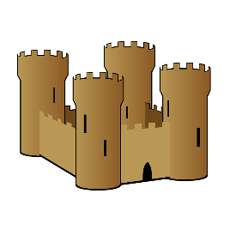
QUESTION | YOUR ANSWER
Who established most of the holidays in the middle ages?

What was the longest holiday of the year?

What were festivals like? What kind of activities were there?

Why were the commoners happy with the church?

How did the church earn both power and money from holidays?

Part 2: Visit the following webpage:
http://www.lordsandladies.org/middle-ages-holidays.htm

- Choose 3 holidays mentioned in the article and describe them.

HOLIDAY | WHAT WAS IT LIKE? | DO WE CELEBRATE A SIMILAR HOLIDAY TODAY?
EXAMPLE:  All Fool’s Day | EXAMPLE:  The jesters took charge for the day and caused a lot of mayhem with jokes & jests! | EXAMPLE:  This reminds me of April Fool’s Day! We play jokes/pranks on each other.
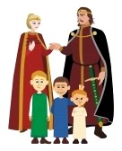
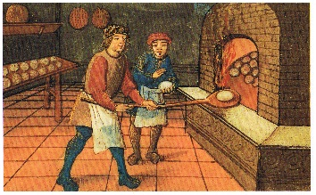
Part 3: Visit the following webpage:
HTTP://TINYURL.COM/ydax5mab

- Read the article
- Answer the questions below

QUESTION | YOUR ANSWER
Why did people take every chance they could to feast?

What was the greatest religious feast? What was it like?

How did people prepare for Christmas in the Middle Ages?

Why were the commoners happy with the church?

What kind of food/drinks would they serve at feasts?

Part 4:

Choose one of the holidays you learned about in today’s webquest. Draw a visual representation of the holiday below! Make sure to think about everything you learned about the holiday. Ex: What season was it in? What would the weather be like? What food/drinks would they have? What would people be doing? You may also want to consider whether your visual representation is of lords/ladies celebrating or serfs/peasants celebrating. How would they celebrate differently?

